Cell Membrane

A cell membrane is the semipermeable membrane surrounding the cytoplasm of a cell.
The cell membrane is selectively accessible to ions and organic molecules and controls the movement of substances in and out of cells. The basic function of the cell membrane is to protect the cell from its surroundings. It lies in the lipid bilayer with embedded proteins.

Cell membrane is made up of three macromolecules. Lipids called Phospholipids make up most of it. Carbohydrates are also a part of the membrane, and it helps cells recognize each other. Proteins serve as carriers and make up another large portion of the cell membrane.

The cell membrane is a thin flexible layer around the cell of all living things. It’s sometimes called the Plasma Membrane or Cytoplasmic Membrane. Its basic job is to separate the inside of cells from the outside. In all cells, the cell membrane separates the cytoplasm inside the cell from its surroundings.

The cell membrane allows things in and out by simple diffusion. During simple diffusion small molecules without charges such as oxygen and carbon dioxide flow through the plasma membrane without assistance and without expending energy. Other substances such as proteins, glucose and charged particles called ions cannot pass through the selectively permeable membrane.

Things get in and out by passive transport. Some elements pass through small holes in the surface of the cell membrane. It’s called diffusion and doesn’t require the cell to expend energy. Oxygen goes into a cell and carbon dioxide lets it be this way.
The cell membrane is important because all living cells contain a cell membrane, the semipermeable structure that develops the cell. This flexible skill is important because it allows the cell to survive in different environments, such as when absorbed in water over long periods of time.
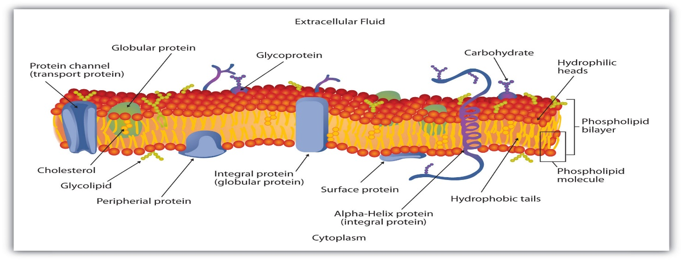
Resources:
https://www.thinglink.com/scene/843553546338041856
https://en.wikipedia.org/wiki/Cell_membrane
http://study.com/academy/lesson/cell-membrane-functions-role-structure.html
https://www.khanacademy.org/science/biology/membranes-and-transport/the-plasma-membrane/a/structure-of-the-plasma-membrane

