Unit 3 Test: Graph Behaviour
The Unit 3 test is overall easier than the Unit 2 test, but that doesn’t mean it’s easy! Go back and look at your previous lessons, any time you see any graph make sure you can answer all the questions from below in question 1. There are 25 questions on this test, only two of them are short-answer (see numbers 10 and 7 on this study guide). After you go through this study guide ask me tons of questions!
- Look at the graph below and answer the following questions (note that each graph line is 2 units, also the vertex of the upside-down parabola is the point (0.297, 4.078))
- Find the intervals over which the function is increasing
- Find the intervals over which the function is decreasing
- Find the vertical asymptotes
- Is this graph continuous or discontinuous. Describe any discontinuities (where are they and what type are they?)
- Find the x and y intercepts of this function
- Is this function even odd or neither?
- Find f(4) both graphically and algebraically.
- Describe the end behavior of the function
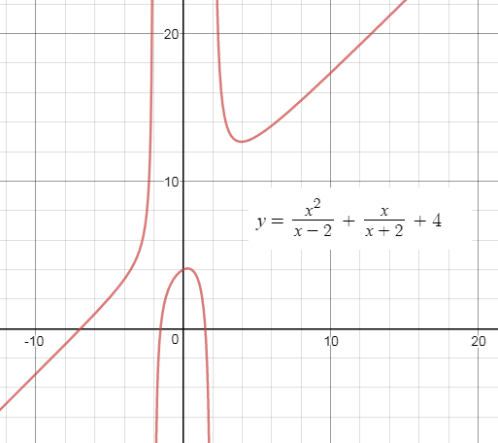
- A constant function is one that is horizontal. For example, y=2 is a constant function. If a questions asks you ‘where is this function constant’ they’re just asking which part of the graph is a horizontal (flat) line segment.
- Review removable, jump, and infinite discontinuities and be able to identify them on ANY graph.
- The identity function is just y = x
- Make sure you know what each of the following parent functions look like:
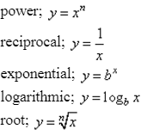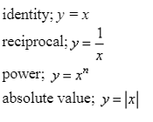
- Practice translating each of the above functions. How can we move them up, left, right, and down. How can we make them fatter or skinnier? How can we flip them over the x-axis and the y-axis? Play around in Desmos!!!
- Short Answer: If I give you a function like 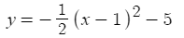 you should be able to tell me what transformations were performed on the parent function (reflected, shifted, and compressed/dilated)
- Which of the functions in part 5 have asymptotes?
- Describe the end behavior of each function in part 5
- Short answer: Identify the key characteristics of the equation from question 7. Include the following: domain, range, intervals where the function is increasing, decreasing, or constant, intercepts, whether the function is even, odd, or neither, whether the function is continuous or discontinuous, asymptotes, and end behavior. You need to include ALL of these things!
Side note: Learning how to struggle is one of the most important things you can learn in High School. Realistically many of you will never use any of the above material in your future life. So why do we learn it? Learning mathematics helps you to think critically and problem-solve logically, both important skills in any career. There is a lot of research that has found that you learn and develop your brain the most when you struggle and get things wrong. It’s good to struggle, it’s okay to fail, it’s important to ask for help, and to never give up.
"A person who never made a mistake never tried anything new." ~Einstein
This is an article about struggle and the importance of persistence. : If you read it and write a one paragraph summary of the article and another paragraph on your opinion and experience I’ll give you one point of extra credit on this Test. This is totally optional and just a small bonus so don’t spend all day on it!

