NOTE: At the bottom of this you will see how to get into safe mode.
- Restart into safe mode.
- Run the script I sent you as an administrator, to do this right click the file and hit “RUN AS ADMINISTRATOR”
- Search RegEdit and run it
- 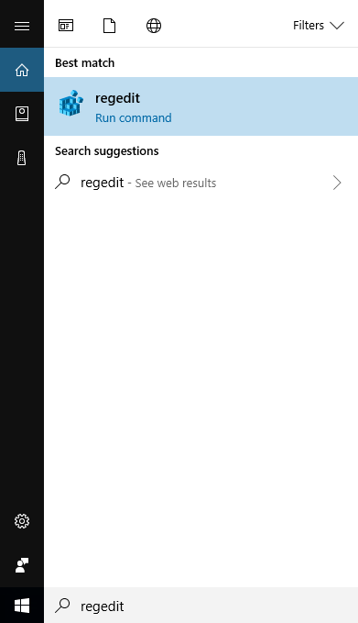
- Select the boxed text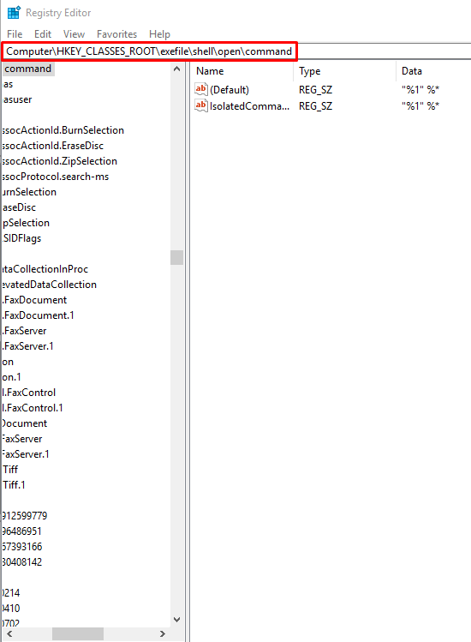
- Replace it with “HKEY_LOCAL_MACHINE\SYSTEM\CurrentControlSet\Enum\Root\LEGACY_BCKD” and hit enter, you will be sent to the registry file we need
- Next, right click the LEGACY_BCKD key from the scroll list on the left, and hit permissions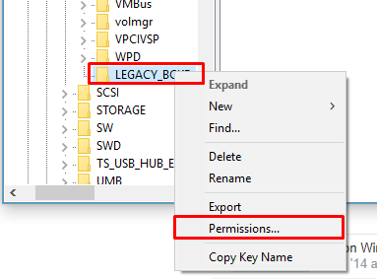
- Click administrators, then click “Advanced” 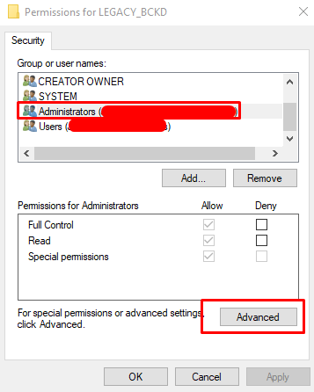
- Check the box that is outlined in this screenshot, then hit ok. 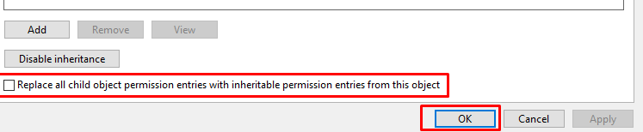
- Select “/users” and grant it the “full control” permission by checking “allow”. Then hit ok.
- Right click the key from before, and instead of hitting permission, hit delete
- Finally restart windows, and k9bluecoat should be disabled if all went well.

2. Use the “Shift + Restart” combination
Another way of getting into Safe Mode in Windows 10 is to use the Shift + Restart combination. Open the Start menu and click or tap on the Powerbutton.
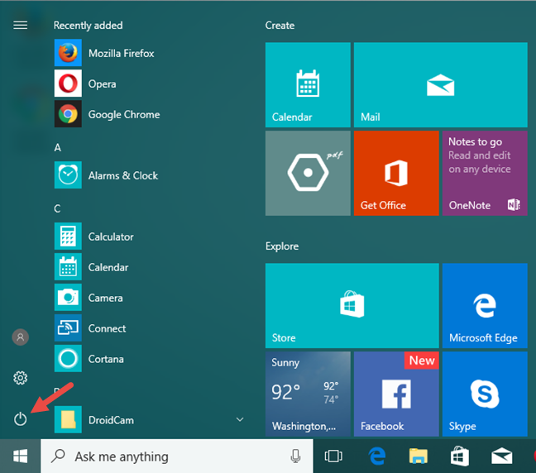
Then, while keeping the Shift key pressed, click or tap on Restart.
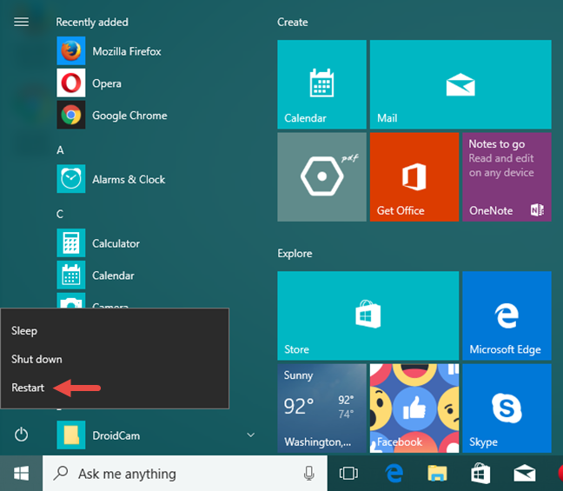
Note that you can also use the Shift + Restart combination from the Sign In screen: click or tap Power, press and hold Shift and then click or tap Restart.

Then, Windows 10 reboots and asks you to select an option. Choose Troubleshoot.
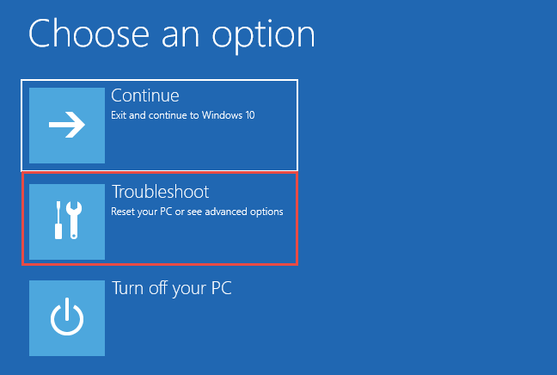
Then, on the Troubleshoot screen, select Advanced options.
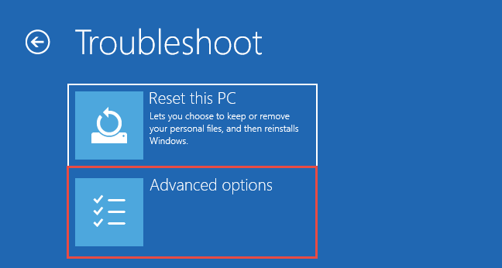
On the Advanced options screen, choose Startup Settings.
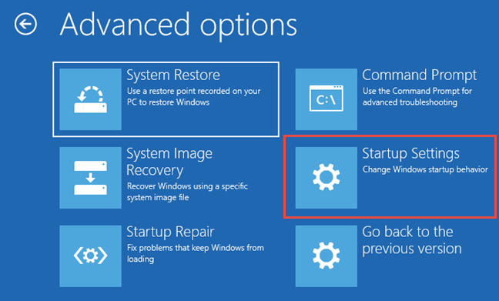
Windows 10 says that you can restart your device to change advanced boot options, including enabling Safe Mode. Press Restart.
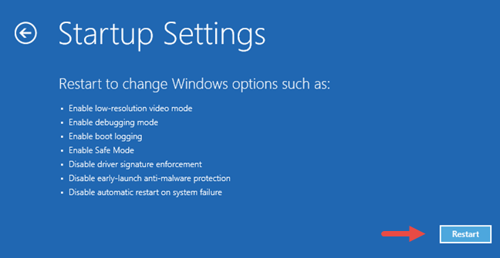
After Windows 10 reboots, you can choose which boot options you want to be enabled. To get into Safe Mode, you have three different options.
To enable Safe Mode press the 4 or the F4 key on your keyboard, to enable “Safe Mode with Networking,” press 5 or F5, and to enable “Safe Mode with Command Prompt” press either 6 or F6.

