Procedure
- Pick one person to be the hand washer and one person to be the timekeeper. You will both have the opportunity to complete each of the experiments, so you will each be washing your hands two times.
For each trial of this experiment, the timekeeper (the partner not washing hands) will be responsible for determining the cleanliness of the washer's hands at each time interval. Use the following scoring guide as a reference.
Scoring Guide:
Completely  Dirty | Very Dirty | Somewhat  Dirty | Slightly  Dirty | Clean
4 | 3 | 2 | 1 | 0
- **Discuss as a team the factors that you will use to determine the level of cleanliness observed at each time interval before you get started.**
- Washer #1 should put a small amount (about a tablespoon) of washable paint on the palm of one hand and spread it evenly over both hands. Be sure to cover the backs of the hands and the skin next to and under the fingernails. Allow the paint to dry completely.
- Go to the sink and blindfold Washer #1 so he or she can't see his/her hands. Turn on warm (not scalding hot!) water. Have Washer #1 wash with just water for one second. After one second, have the timekeeper blot dry the washer's hands by very lightly touching the paper towel to the skin (do not rub!). Use the scoring guide to record the cleanliness on the "water only" data table in the row marked "Washer #1." Do not let Washer #1 see his/her hands, and be sure that you do not give away any hints about how clean they are.
- Have the washer wash for four more seconds with just water. Again, lightly blot the washer's hands and record their cleanliness in the data table.
- Have the washer wash for 15 seconds more with water. Once again, blot and record the cleanliness on the data table.
- Take the blindfold off and allow the washer to completely clean his/her hands.
- Change roles and repeat steps 2 through 6 with Washer #2. Record these results on the second row of the data table, under "Washer #2."
- Now change roles again so that Washer #1 is back to the role of hand washer. Repeat steps 2 through 6, having the washer use soap each time. Record the results in the appropriate row of the data table.
- It is now time for Washer #2 to repeat steps 2 through 6 using soap each time. Record these results in the second row of the data table.
Data and Observations:
For each trial of this experiment, the timekeeper (the partner not washing hands) will be responsible for determining the cleanliness of the washer's hands at each time interval. Use the following scoring guide as a reference.
Scoring Guide:
Completely  Dirty | Very Dirty | Somewhat  Dirty | Slightly  Dirty | Clean
4 | 3 | 2 | 1 | 0
Data Table:
Use the scoring guide above to record the level of cleanliness at each time interval.
Water Only:
Total wash time  (in seconds) | 0 seconds | 1 second | 5 seconds | 20 seconds
Washer #1 | 4 | 4 | 2 | 1
Washer #2 | 4 | 2 | 1 | 1
Average  Cleanliness Score | 4 | 3 | 2 | 1
Soap and Water:
Total wash time  (in seconds) | 0 seconds | 1 second | 5 seconds | 20 seconds
Washer #1 | 4 | 4 | 3 | 1
Washer #2 | 4 | 4 | 2 | 0
Average  Cleanliness Score | 4 | 4 | 2 ½ | 0 ½
Data Analysis:
Create two graphs showing the average cleanliness score at each time interval. One graph will show the average results with water only and the other will show the average results for soap and water. Total time washed should go on the horizontal x-axis (marked from 0 to 20 seconds) and the cleanliness rating should go on the vertical y-axis.
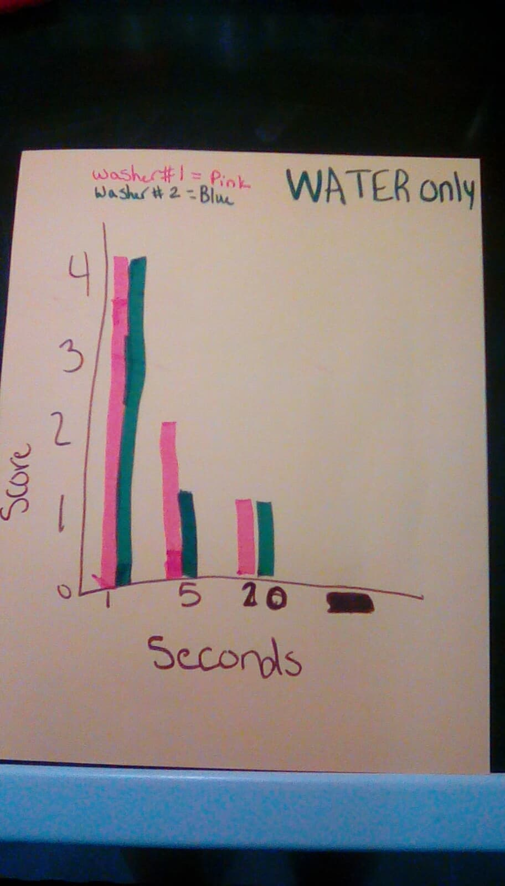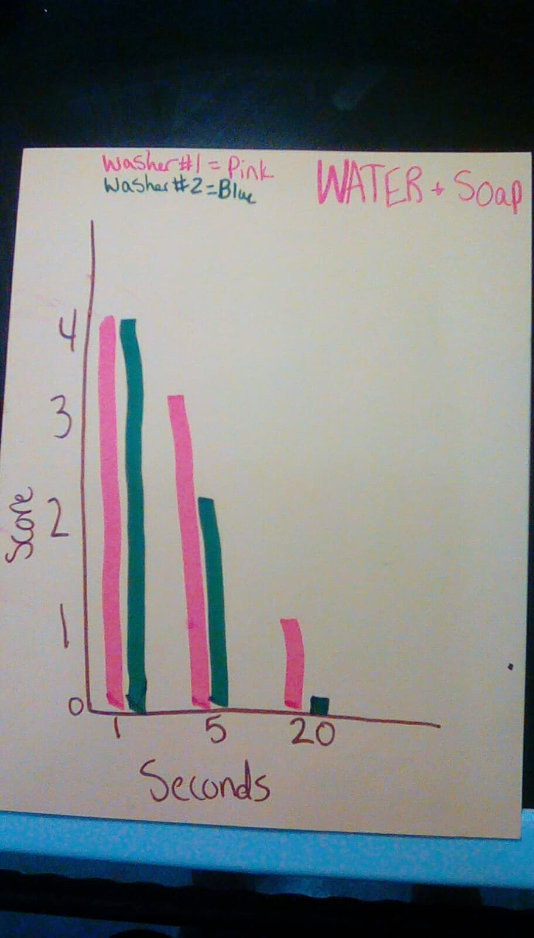
Conclusion:
Be sure to answer the following reflection questions in the conclusion paragraph(s) of your lab report:
- How do the results of the four trials compare?
The first trial went ok. With just using water I worried the paint would stain my partner’s hands but at the end worked pretty well. The second trial worked pretty much the same way trial one went but with my hands bigger it cleaned my hands faster because I could wash a bigger area at each time. The third trial went well because the soap helped a lot. The soap made it easier to wash the hands faster and it makes it were you don’t worry if it will stain. The fourth and final trial went the same as the third trial the soap helped a lot with the paint and made it easier to wash the hands without worry it will stain or leave any left overs.
- What, if any, errors or inconsistencies may have occurred in this experiment?
If any errors happened we made sure that we restarted to make sure that the results were 100% correct.
- What suggestions do you have for improving this lab and minimizing errors or inconsistencies? Be specific.
If i added any suggestions the suggestions would be making sure you have paper towels on the surface so no staining will happen. And make sure you wear clothes you don’t care about so they don’t get ruined by the pain.
- Based on these results, what is the importance of soap and time for effective hand washing?
Based on these results you should wash your hands with soap for at least 30 seconds to 1 minute.
- What areas of the hands retained the paint the longest, requiring careful scrubbing to get clean?
Under the finger nails still retained paint and on top of the finger nails retained paint.
- Analyze the graphs. What do they indicate about the time it may take to effectively wash your hands?
The graphs show that you need to use soap and wash your hands for 30 seconds to get them completely clean.
- Describe the various defense mechanisms your body has to fight pathogens, nonspecific and specific. How does not washing your hands properly affect these mechanisms?
The First Line of Defense is External which means your skin protects the body from many pathogens and foreign substances encountered in your everyday life. The Second Line of Defense is Internal which means when your sick and have a fever your body temperature heightens and speeds up important immune responses. And the Third Line of Defense is The Immune System which means The cytotoxic T cells destroy the infected body cells inside your body which will make it were your not sick. Not washing your hands makes the risk of not getting sick higher .

