When quoting from an electronic book where there are no page numbers but locations.

“Example of Quotation from book” (Name of Author , Publication Date, Page #)
“They can, therefore, serve as the architect or orchestra leader for the mind’s many functions” (Greenspan & Shanker , 2004 , location 658).

Rest of the information (credit) needs to be in a separate reference sheet.
Author , Publication Date , Title of Book or Article, Etc.
Publisher Location: Name of Publisher , Type of Material

Greenspan, S.I. & Shanker , S. G. (2004). The first idea: How symbols, language evolved.
Cambridge , MA: De Capo Press (Kindle Edition)

When quoting from a printed book where there are page numbers.

Name of Author (Publication Date) said, “Quotation goes here” (page number)

Dewey (1916) said, “When an activity is continued into an undergoing of consequences, it is loaded with significance” (p. 139)

Rest of the information (credit) needs to be in a separate reference sheet.

Author , Publication Date , Title of Book or Article, Etc.
Publisher Location: Name of Publisher , Type of Material

Dewey J. (1916). Democracy and Education.
New York, NY: The Free Press

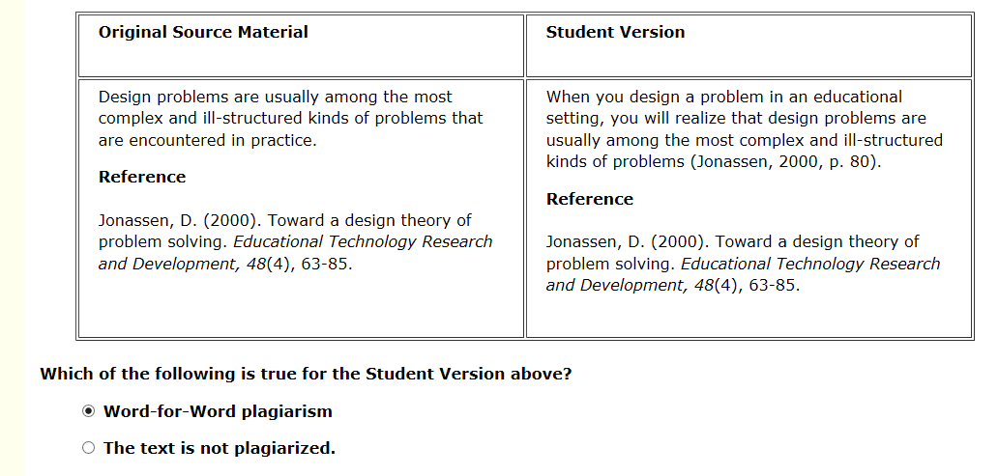
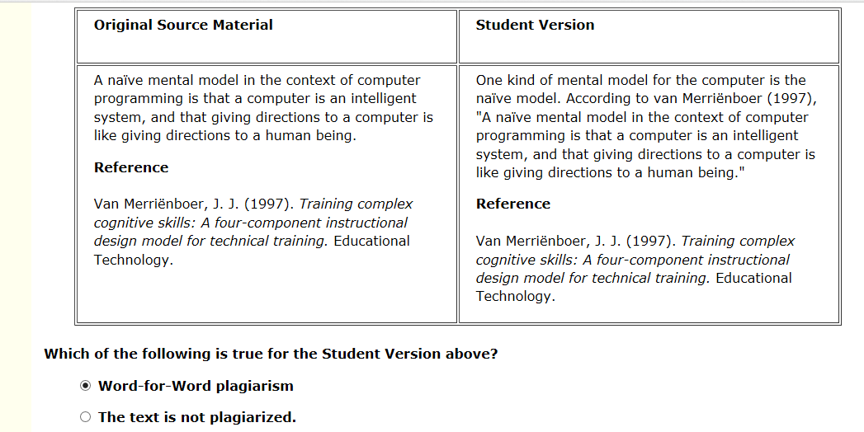

You commit Paraphrasing plagiarism if your writing or speech:
  - borrows ideas from the original source material, and
  - does not contain seven or more words in sequence taken from the original source material, and
  - lacks any of the following:
    - the in-text citation with author name(s) and date (specific locator is not required)
    - the bibliographic reference.

When summarizing the overall idea from an entire book written by two authors.

Author Name(s) (Date of Publication) conclude that ……………………………………………………………….

Greenspan and Benderly (1997) conclude that emotions arising through engagement is fun

When quoting directly from two different locations from the same source

To make sure you don’t do word for word plagiarism:
- put quotations around the quotes that are directly from the book, article, etc.
- Do the citation: Author (Publication Date) “Quote…” (Page Number at end of quote)
- Write the Reference in the Reference Page: Author , Publication Date , Title of Book or Article, Etc. Publisher Location: Name of Publisher & Volume & Edition , Type of Material

When paraphrasing and directly quoting from the same source.

- Put in quotations words that are not yours
- Always write in the reference as well on the reference sheet

More than 7 words copied is word for word plagiarism

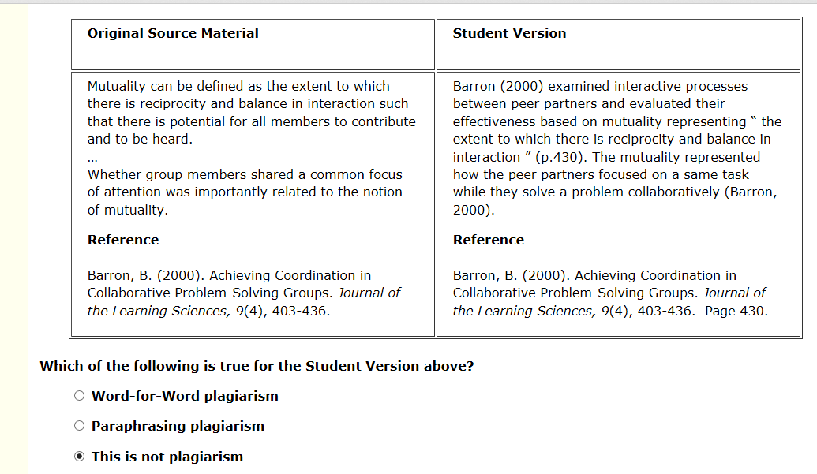
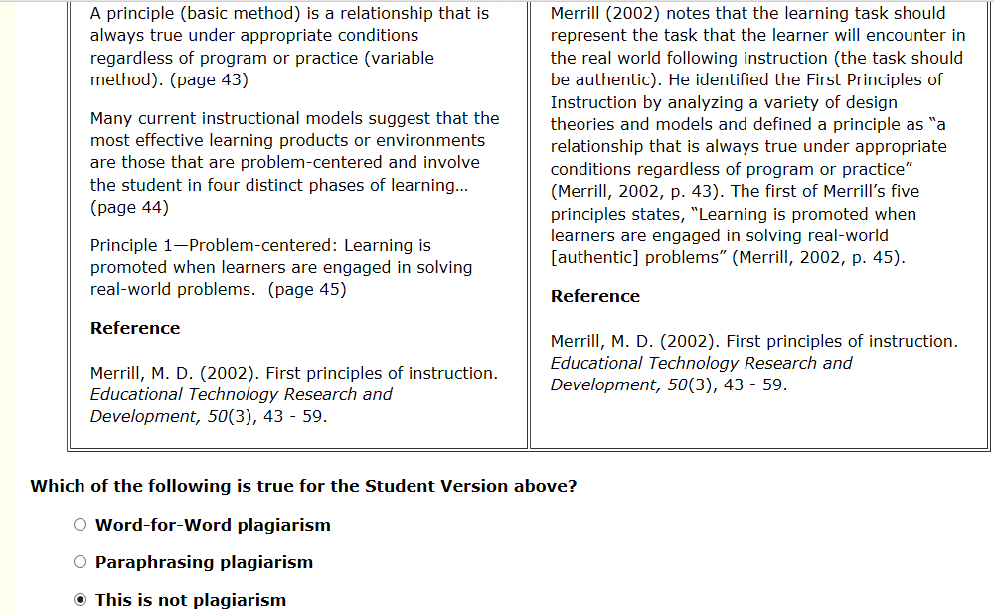
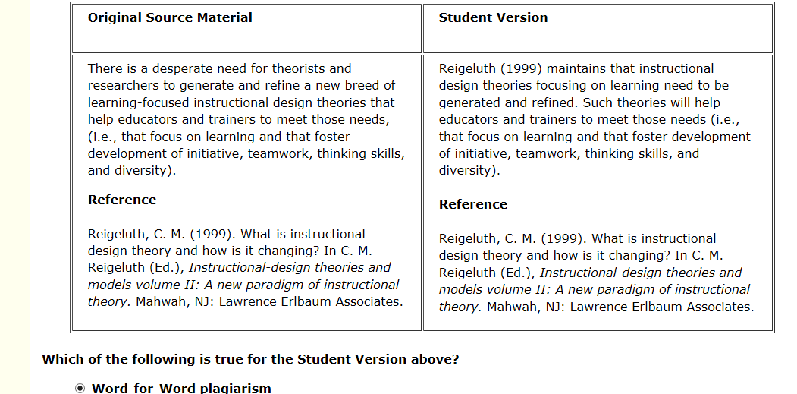
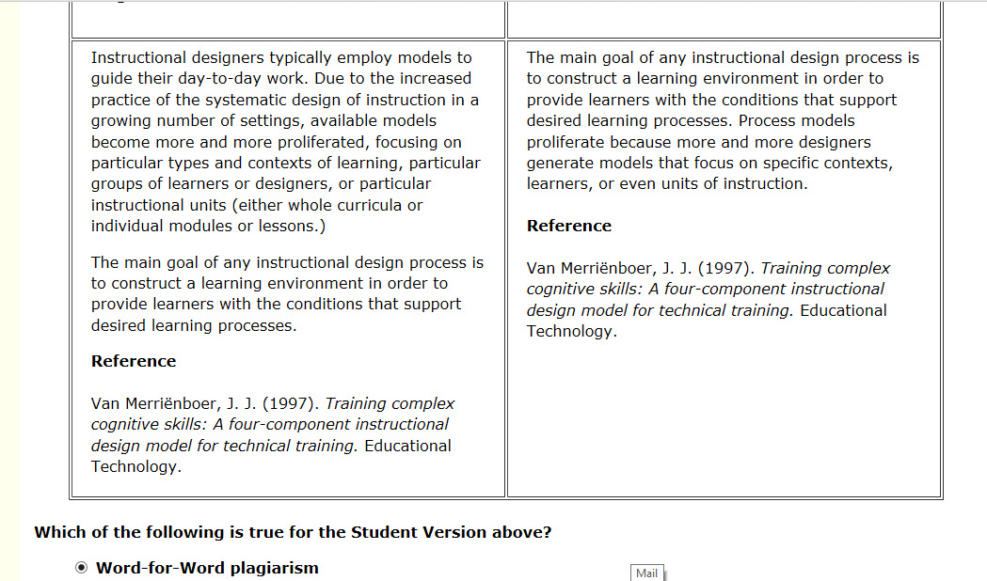
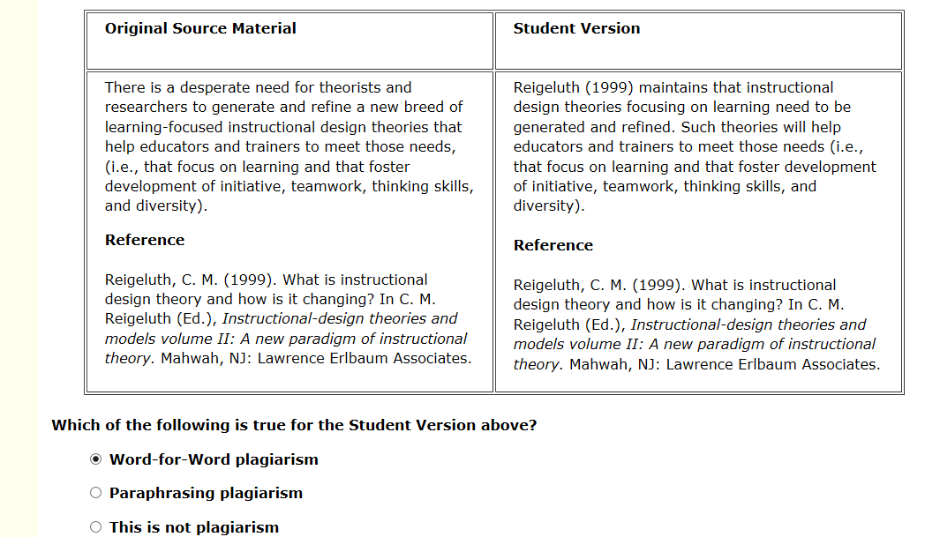
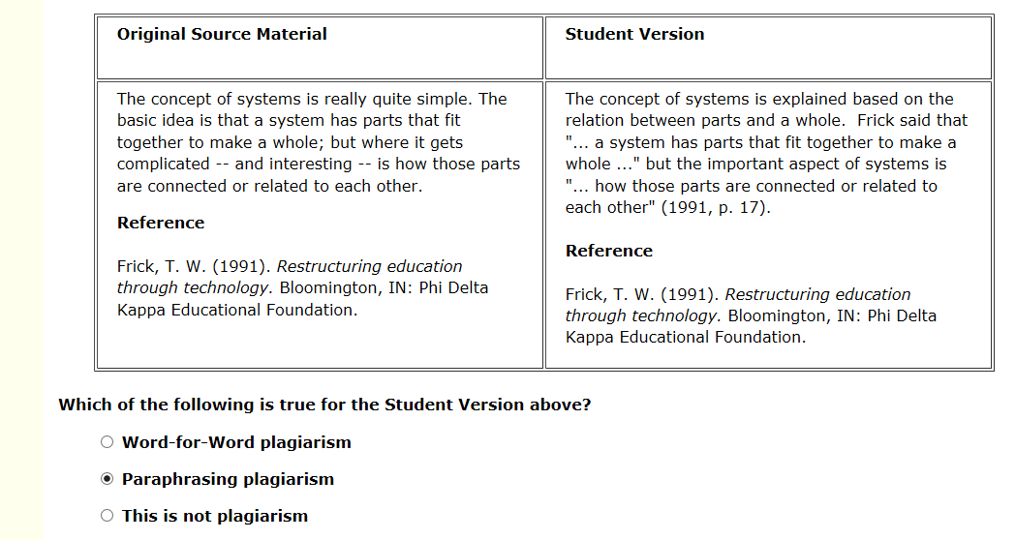
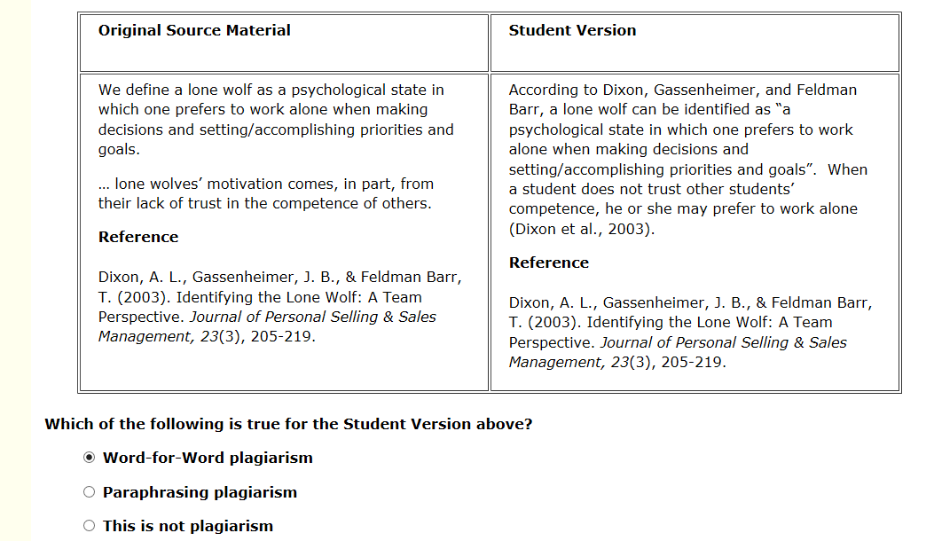
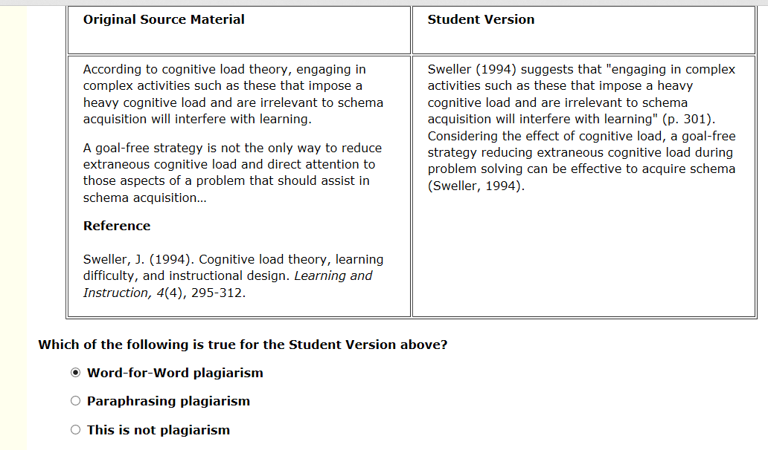

How to write a paragraph with your own words but ideas of someone else

- Whatever credit is given in the text : Author (Pub. Date) “Quote” (Page #),,,, It needs to be in the Reference Sheet

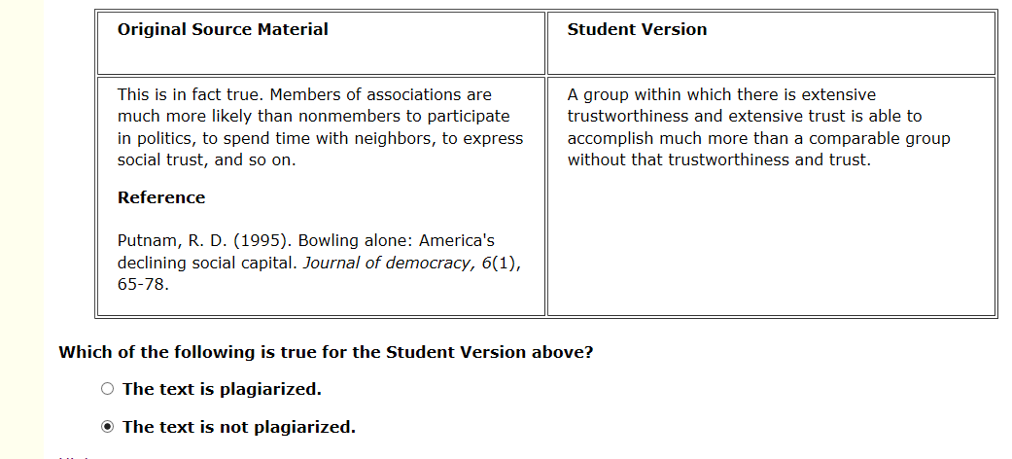
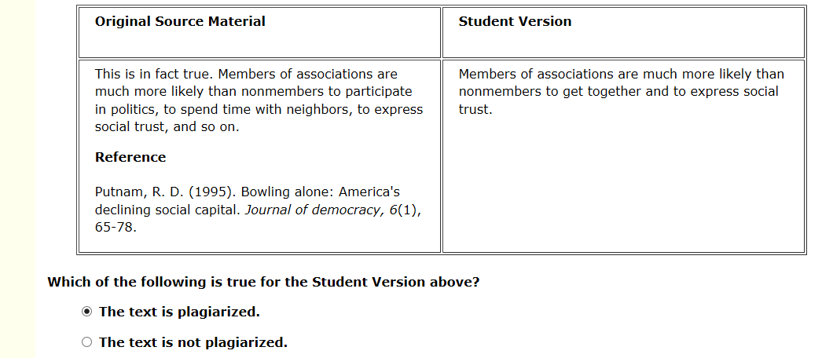
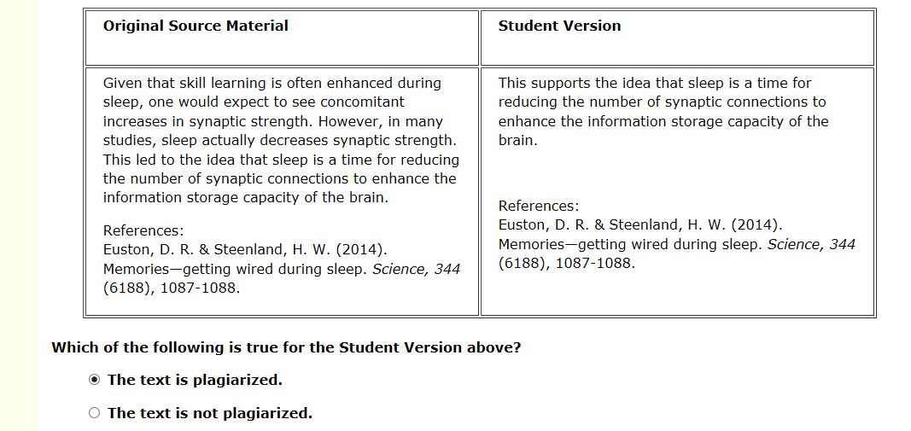
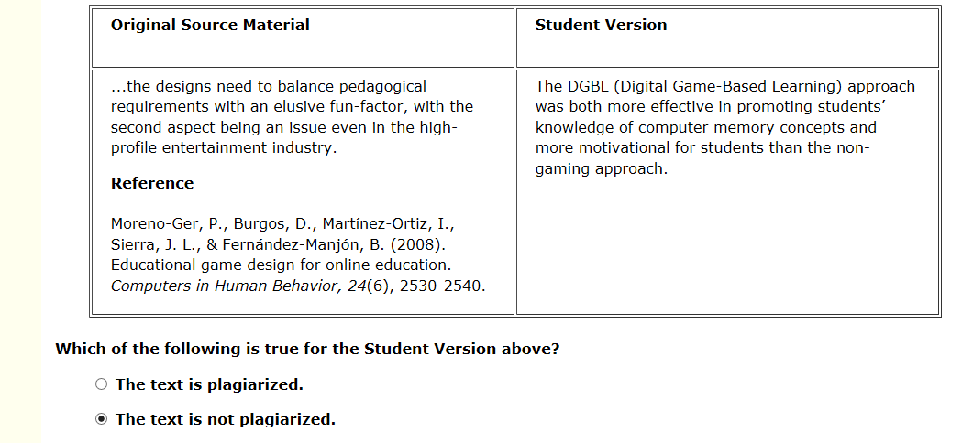

Different Lessons

