The Secret
Episode 6: Deep with in
Luna: *eyes turn purple* Not happening *cuts jackson’s arm off*
Jackson: AAAAAAAAAAAA! HOW HOW DARE YOU! *his eyes turn blood red and electricity starts shooting from his body*
*a bolt of electricity shoots off his body and shoots at luna*
*as the bolt goes toward luna scarlet appears and takes the bolt of electricity and wields it and changes its structure and adds fire to it and shoots it back*
BOOM *it sends Jackson in the air*
Luna: Whoa scarlet how did you do that
*scarlet looks up and luna look at her eyes*
*Scarlet has one red eye one yellow eye*
Luna: Scarlet you didn’t
Scarlet: im sorry we had no other choice *looks up at Jackson*
Jackson: *stands up and holds his leg* *looks up* *gasp* They merged
Scarlet: LISTEN JACKSON IF YOU WANT TO BRING THE BLACK EYED WITCH BACK TO LIFE YOUR GONNA HAVE TO KILL ME FIRST
Luna: Scarlet what are you doing is clem safe
*Scarlet looks at Luna*
*Scarlet places her finger on luna’s head and it shows a vision of what happened in the forest*
Luna: *gasp* *smiles* That’s my girl
Scarlet: Luna I need you to transform
Luna: what?! We haven’t been able to hold the form tho it will just be a mess
Scarlet: LUNA this is not the time to think things over this is do or die
Luna:*looks at scarlet* Alright ill do my best *luna sits down and closes her eyes and focuses all her power*
Scarlet: *looks at Jackson* if you plan to survive you might wanna think on powering up *smirks*
Jackson: *thinks* no wonder why kojak had some trouble these girls just keep pulling out surprises
Jackson: *smiles* if you wish *a bright blood red aura appears around Jackson and it get brighter and bigger*
Jackson: *his hair turns red and his eyes turn red with electricity bolts shooting through them* *smiles* there
Scarlet: *thinks in head* you ready *clems voice* ready *luna has a blue aura around her and it starts to glow *
Scarlet: *A red and blue aura starts to swirl around her both electricity and fire starts to form in this aura.*
*A bright yellow light appears and scarlet turned into a different being*
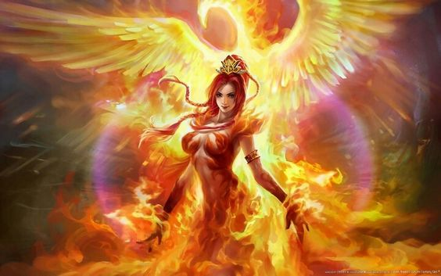
*Jackson’s eyes grow big*
Jackson: Yes *smiles* You just made my job easier
Scarlet: LUNA ILL KEEP HIM BUSY JUST FOCUS AND BECOME ONE WITH IT
*scarlet looks at Jackson*smiles*
*Scarlet and Jackson jump in the air and go towards eachother *
*Jackson shoots a electric bolt towards scarlet and she takes it and shoots it back and it turns blue with red flames swirling around it*
*Jackson doges it and when he looks back Luna is in his face with a blue eye and one black eye and a crack in her face*
*Luna Smiles* * and touches jackson’s shoulder and evaporates his armor*
Jackson: What are you doing
*Scarlet puts her hand on luna’s shoulder*
*Luna and scarlet out there hands together and a huge red,blue,black and purple sparks and flames appear around there hands*
*Luna’s eyes glow black while scarlets eye glow white*
*Jackson goes to back up but behind him is Akuma and kumori Spirits and they hold the lion in place*
Jackson: NO NO LET GO OF ME NOOOOOOOOO
*as scarlet and luna shoot the blast at Jackson a bright blue light appears around Jackson*
*jackson’s eyes are white and his hair turns blue and the lion spirit starts showing him self*
*Jackson starts laughing like a crazy person* *his voice mutates*
Luna: No he merged with his spirit he he lost him self in it
*Jackson starts floating in the air as the lion starts to form on the out side*
Scarlet: Luna we have to merge
Luna: Scarlet im barely able to stay in control in this form I don’t know if I can go any more
Scarlet: Luna Trust me it’s the only way
Luna: scarlet I don’t think it will work
*scarlets eyes glow blue*
*clementines voice comes through*
Clem: MOMMY YOU NEED TO STOP THINKING AND DO AS AUNT SCARLET SAYS TRUST HER
Luna: *looks at scarlet* *sighs* fine
*scarlet grabs her hand and puts it flat against hers and her eyes glow purple and so does luna’s*
*a bright purple light shoots of the two girls*
Jackson: *voice mutated* *laughing* DON’T YOU DARE! *swings at the girls* YOU MUST DIE
Akumori: *laughing* long time no see leo
Leo: Ak…….akumori
Akumori: Yes leo *twist his hand and throws him to the ground*
*Akumori Floats to leo*
Akumori: How dare you think you could beat us *looks at him* we are the goddesses of the shadows and light and you think you could beat us *laughs* your even more pathetic now than you were 1,000 years ago
Akumori: just because you find a boy to take over doesn’t mean it makes you stronger
Leo: *grabs Akumori’s neck* But what if it does *throws her to the gorund*
*Luna floating in a black world unconscious*
*black goop starts to cover her body slowly absorbing her*
*whispering*
*scarlet in the same situation*
*red lights shoot off scarlets body* *and melts the goop*
*Her eye open red*

