Study Guide

Interim 1 Assessment

RL.2 Determine a theme or central idea of a text and analyze in detail its development over the course of the text, including how it emerges and is shaped and refined by specific details; provide an objective summary of the text.
RL.3 Analyze how complex characters (e.g., those with multiple or conflicting motivations) develop over the course of a text, interact with other characters, and advance the plot or develop the theme.
RL.4
RL.5 Analyze how an author's choices concerning how to structure a text, order events within it (e.g., parallel plots), and manipulate time (e.g., pacing, flashbacks) create such effects as mystery, tension, or surprise.
RL.7 Analyze the representation of a subject or a key scene in two different artistic mediums, including what is emphasized or absent in each treatment
RL.9 Analyze how an author draws on and transforms source material in a specific work
RI.4 Determine the meaning of words and phrases as they are used in a text, including figurative, connotative, and technical meanings; analyze the cumulative impact of specific word choices on meaning and tone
L.1b Use various types of phrases (noun, verb, adjectival, adverbial, participial, prepositional, absolute) and clauses (independent, dependent; noun, relative, adverbial) to convey specific meanings and add variety and interest to writing or presentations.

Arachne the Spinner

A long time ago in a place called Lydia lived a young spinner and weaver called Arachne. Lydia had a reputation for producing splendid textiles and had some of the finest spinners and weavers in the world. No spinner or weaver was more talented or gifted than Arachne.
Arachne wove all sorts of beautiful pictures into her cloth. Often the scenes were so life like that people felt they could almost touch and feel what was going on. Visitors travelled many miles to see her beautiful work. Not only were her finished products beautiful to look at, but just watching her weave was a sight to behold. Even the nymphs of the forest would stop their play and look on in wonder.
Arachne was rightly very proud of her work but she was also very arrogant. So remarkable were her works that observers often commented that she must have been trained by Athena, the goddess of wisdom and crafts, also known for her ability to spin and weave beautiful pictures. Arachne was scornful of this. Why she said, should she, with all her talent, be placed in an inferior place to the goddess? She would tell visitors that the Goddess herself could not produce work any better.
When news of Arachne's bold claim reached Athena she was very angry, but she decided to give the young woman a chance to redeem herself. So one day she disguised herself as an old peasant woman and went to visit Arachne. She gently warned her to be careful not to offend the gods by comparing her talents to those of an immortal.
But Arachne told the old woman to save her breath. She boasted that she welcomed a contest with Athena, and, if she lost, would suffer whatever punishment the goddess decided.
At this Athena revealed her true form. The visitors who had come to watch Arachne's weaving were very afraid, but Arachne stood her ground. She had made a claim, and she would prove it.
It was decided they would compete by each creating a tapestry. The two of them set up their looms in the same room and the contest began, the mortal Arachne at her loom and the goddess Athena at hers. They wove from early in the morning until it got too dark to see. The next day they compared what they had done.
Athena had woven a stunning cloth showing the gods and goddesses together on Mount Olympus doing good deeds for people. A beautiful scene had developed from the threads. Those witnessing the competition marveled at the work produced by the goddess. Arachne, however, had woven a cloth that made fun of the gods and goddesses. It showed them getting drunk and behaving very badly. Nevertheless, so exquisite was the mortal's work that the characters in the scene were lifelike.
When Athena saw it she was even angrier than she had been before. She was forced to admit that Arachne's work was flawless but the disrespectful choice of subject made her finally lose her temper. Athena destroyed Arachne's tapestry and loom. Then she touched her forehead, making sure that she felt guilt for her actions.
Arachne was ashamed but the guilt was so overwhelming it was far too deep for a mortal to bear. Realizing her folly Arachne was crushed with shame. Terrified and in turmoil she ran into a nearby wood and hanged herself from a tree.
Athena had not expected Arachne to take her own life and took pity on her.
Sprinkling Arachne with the juices of the aconite plant, Athena loosened the rope, which became a cobweb; then she said gently, "Spin if you wish to spin". At this Arachne slowly came back to life but not in human form, for as Athena spoke her words Arachne's nose and ears disappeared, her arms and legs became long and slender and new legs grew beside them, then her whole body shrank until she was just a tiny little spider.
For the rest of her life Arachne was to hang from a thread and to be a great weaver and the descendents of Arachne still weave their magic webs all over the earth today.
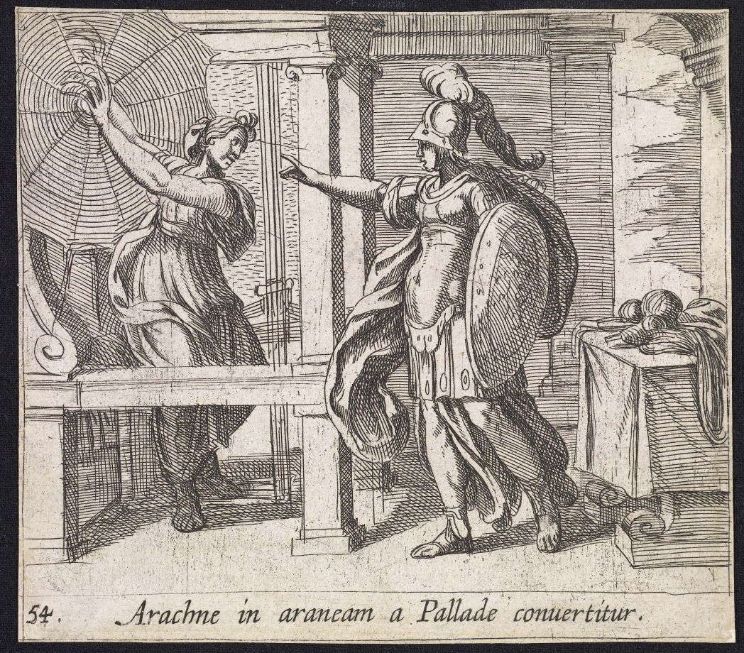

1. How does the archetype of the ruler, exemplified by Athena, affect the story? RL.4
a. it establishes Athena as a character capable of change
b. it causes readers to fear Athena and her powerclik it
c. It allows Athena to exhibit power over Arachne’s emotions and existence
d. it allows Athena to control the situation to ultimately win the contest
A
2. How would you characterize Arachne using traditional archetypes? Use evidence from the text to support your answer. RL.4

3. How does the author create surprise in this myth? RL.5
a. the author sets up Athena as cruel, but she shows pity on Arachne and lets her live
b. the author foreshadows that Arachne will win the spinning contest
c. the author draws a parallel between Arachne and Athena by comparing their talent
d. the author sets up the expectation that Athena will win the contest because she is a god
A
4. List the similarities between the story and the image. RL.7

5. What information does the image provide that the story does not? RL.7

6. How does the text represent Athena differently than the image? RL.7

7. Which quotation from the text best shapes the theme that pride is a limitation that humans suffer? RL.2
a. “Arachne wove all sorts of beautiful pictures into her cloth. Often the scenes were so life like that people felt they could almost touch and feel what was going on. Visitors travelled many miles to see her beautiful work.”
b. “When news of Arachne's bold claim reached Athena she was very angry, but she decided to give the young woman a chance to redeem herself.”
c. “For the rest of her life Arachne was to hang from a thread and to be a great weaver and the descendents of Arachne still weave their magic webs all over the earth today.”
d. “Arachne, however, had woven a cloth that made fun of the gods and goddesses. It showed them getting drunk and behaving very badly.”
D
8. Summarize the initial interaction between Arachne and Athena in the story. Why does it happen? What is Athena’s motivation for visiting Arachne?

9. How does the initial interaction between Arachne & Athena affect the story? RL.3
a. it presents Athena as a powerful god who will not tolerate criticism
b. it sets the stage for Athena and Arachne to be friends
c. it demonstrates that Arachne’s pride may be a weakness instead of a strength
d. it forces Athena to prove that she is more talented than Arachne
A
10. How does Athena’s decision to allow Arachne to feel guilt affect the plot of the story? RL.3

11. How does Arachne’s decision to hang herself affect the plot of the story? RL.3?

Ozymandias

I met a traveller from an antique land
Who said: Two vast and trunkless legs of stone
Stand in the desert...Near them, on the sand,
Half sunk, a shattered visage lies, whose frown,
And wrinkled lip, and sneer of cold command,
Tell that its sculptor well those passions read
Which yet survive, stamped on these lifeless things,
The hand that mocked them, and the heart that fed
And on the pedestal these words appear:
'My name is Ozymandias, king of kings:
Look on my works, ye Mighty, and despair!'
Nothing beside remains. Round the decay
Of that colossal wreck, boundless and bare
The lone and level sands stretch far away

12. Which lines from the poem reflect the central idea that power is temporary? RL.2
a. “Tell that its sculptor well those passions read
Which yet survive, stamped on these lifeless things,
The hand that mocked them, and the heart that fed”
b. “Nothing beside remains. Round the decay
Of that colossal wreck, boundless and bare
The lone and level sands stretch far away”
c. “I met a traveller from an antique land
Who said: Two vast and trunkless legs of stone
Stand in the desert...”
d. “And on the pedestal these words appear:
'My name is Ozymandias, king of kings:
Look on my works, ye Mighty, and despair!'”

13. Based on the poem as a whole, who does “the heart that fed” refer to? RL.4
a. the traveler
b. the sculptor
c. the speaker
d. Ozymandias

14. Read these lines from the poem
Two vast and trunkless legs of stone
Stand in the desert...Near them, on the sand,
Half sunk, a shattered visage lies
How do the images of a broken and forgotten statue effect the meaning of the poem? RL.4
a. They are reminders that power and life are temporary
b. They are reminders that power can corrupt
c. They imply that corruption ruined this once great king
d. They stress the speaker’s relationship with his/her own past

15. Based on the information in the poem, who was Ozymandias?
a. a writer
b. a king
c. a sculptor
d. a travler

16. Based on the context clues in the poem, what does the word “visage” probably mean?
a. a person’s face
b. the remains of a once thriving culture
c. the likeness of a great king
d. someone who’s been dead a long time

17. How does the poem’s structure affect its meaning?
a. The images presented of a crumbling statue lead the reader to believe that this traveler must have been in search of a powerful historical figure
b. The quote on the base of the statue confirms that Ozymandias thought himself to be more powerful than God
c. The setting of the poem in the desert makes the reader feel as if desolation is always the result of power
d. The framing of a story within a story serves to distance the narrative from the reader, thus confirming that the power of history is greater than the power of man

Passover
It’s a far, far road from Egypt
To our own, our happy land,
From the pyramids of Egypt
Built beneath the tyrant’s hand;
Its road so strange and marvelous
That few can understand.
See, the Lord had passed us over
For his sign upon our gate!
He has spared the crushed and driven,
He has judged the proud and great.
When the hosts of Israel rise to go
He makes the crooked straight.
It’s a far, far road to Zion
For the slave afraid to flee;
He must pass through flood and desert,
Yet his land he shall not see.
But the man that knows the sign of God
On Pesach eve is free.

The Passover Story
The Passover story begins when the Pharaoh, the ruler of Egypt, starts worrying that the Jews living in Egypt will outnumber his own people. His response: forcing them into slavery, and decreeing that every son born to the Hebrews should be drowned in the Nile. One baby, named Moses, is saved and adopted by Pharaoh's own daughter.
When Moses grows up, he's told by God to command Pharaoh to let the Jews go. Pharaoh says no, and God sets out to convince him by way of the Ten Plagues. As the story goes, during the tenth and final plague, God passes through the land of Egypt and strikes down the firstborn of every household. But the Jews have been told to mark their doors with the blood of a lamb they've sacrificed — the Passover offering — and so God "passes over" their homes. Jews give thanks for being "passed over" and protected from the plagues: it's a reminder that even when Jews are oppressed, the Bible teaches that they are a chosen people and will survive.
Pharaoh's son is killed during this final plague, and as a result, Pharaoh lets the Jews go free — before changing his mind, as Pharaohs do. The ensuing chase ends up with Moses being trapped in front of the Red Sea, before it's parted by God for the Jews to cross — the act of divine intervention that finally leads them to freedom, and (after forty years in the desert) to the land of Israel.

18. Read these lines from the poem. They refer to the biblical story of the Israelites.
It’s a far, far road from Egypt
To our own, our happy land,
From the pyramids of Egypt
Built beneath the tyrant’s hand;
Its road so strange and marvelous
That few can understand.
Which tone is created by the allusion to the strange and marvelous miracles of God in the story of Passover? RL.4
a. it creates a cautionary tone
b. it implies a doubtful tone
c. it suggests a menacing tone
d. it sets a dramatic tone

19. How does the poem "Passover" show the influence of the story of Passover from the Bible? RL.9
a. both texts convey the idea that people in slavery will eventually rebel
b. the poem discusses the historical aspects of slavery in Egypt during the Pharaoh’s reign
c. both texts emphasize the danger of not trusting God’s plan
d. the poem emphasizes that those who trust God will be made free

20. What is one way that the poem uses source material from the story of Exodus in "Passover"? RL.9
a. the poet shares the story of the Israelites path to freedom to develop the theme that those who trust in God can also be free.
b. the poet uses the example of the enslavement of the Hebrews to demonstrate the consequences of rebelling against authority
c. the poet draws from God’s judgement of the Pharaoh to emphasize the danger of corrupt power
d. the poet uses the detail of being passed over to convey the idea that everyone should believe in God

21. How does the poet incorporate elements of the story of Exodus in "Passover"? RL.9
a. he highlights the building of the Egyptian pyramids to demonstrate that a single person can have great influence over many
b. he contrasts slavery with freedom to remind readers that slavery still exists
c. he shares the Israelites story of freedom to remind Jews of the meaning of Passover
d. he compares the complicated road of the Israelites to freedom to the choice that everyone must make about their own beliefs

22. Read this sentence from the text:
Jews give thanks for being "passed over" and protected from the plagues: it's a reminder that even when Jews are oppressed, the Bible teaches that they are a chosen people and will survive.
Which response best captures the meaning of the sentence? RI.4
a. The Jewish religion believes that any hardship can be overcome by choosing to trust in God’s salvation
b. the story of Exodus is effective in helping an entire culture deal with persecution
c. Biblical stories must contain some kind of supernatural protection from God to be effective
d. The Passover story proves to explain why Jews believe they are God’s chosen people

23. Read these sentences from the text.
The Passover story begins when the Pharaoh, the ruler of Egypt, starts worrying that the Jews living in Egypt will outnumber his own people. His response: forcing them into slavery, and decreeing that every son born to the Hebrews should be drowned in the Nile.
How does the word choice in these sentences affect the tone? RI.4
a. it creates a puzzled tone that hints of the author’s inability to comprehend the back story
b. it sets a disgusted tone that shows how the Pharaoh used his power for evil
c. it reveals a critical tone for any non-Jew living in Egypt at the time who would allow this to happen
d.it shows the author’s disapproving tone at the enslavement of a whole race of people

24. Read this sentence from the text:
Pharaoh's son is killed during this final plague, and as a result, Pharaoh lets the Jews go free — before changing his mind, as Pharaohs do.
How does the word choice in this sentence reflect the author’s attitude about the ancient rulers of Egypt? RI.4
a. it creates an angry tone
b. it develops an appreciative tone
c. it sets a critical tone
d. it suggests a condescending tone

25. Which revision of the sentence uses an adjective phrase to add more detail? L.1b
The girl shot the arrow into the center of the target.
a. The girl with the green shirt shot the arrow into the center of the target.
b. During the final round of competition, the girl shot the arrow into the center of the target.
c. The girl shot the arrow through the trees and into the center of the target.
d. The girl, my sister, shot the arrow into the center of the target.

26. Which revision of the sentence uses an adjective phrase to add more detail? L.1b
Crystal built a fort in the forest.
a. Crystal built a fort in the forest in the late afternoon.
b. Crystal built a fort and spread a large tarp over it in the forest.
c. Crystal built a fort with a big fence in the forest.
d. Crystal, a middle school student, build a fort in the forest.

27. Which revision of the sentence uses an adjective phrase to add more detail? L.1b
Billy drew a picture for his dad.
a. Billy, bursting with excitement, drew a picture for his dad.
b. Billy, my older cousin, drew a picture for his dad.
c. Billy drew a picture with a red crayon for his dad.
d. Billy drew a picture of a red car for his dad.

28. Revise the following sentences and add an adjective phrase: L.1b
a. Sally played a game with her friend.
b. Jacob sewed a blanket for his baby brother.
c. Jaden wrote a letter to his teacher.
d. Molly drove her car to the grocery store.
e. Brian painted the walls of his bedroom.

