Name:
Date:

Graded Assignment

Final Project, Part I
For this Final Project, create a folder titled Final_Project_Your_Name. Save all the project documents in that folder.
Total score: ____ of 75 points

Section 1: Create a Flyer with a Picture and a Table
Problem: Unique Physique distributes a four-color brochure to each of its clients and displays them in local businesses. The center manager has asked you to create a monthly two-page flyer to accompany the brochure.
Instructions, Part 1: Using the information in Figures 1 and 2 below, create the flyer. Enter the text and table in the flyer, checking spelling as you type, and then format it as shown in the figure. Locate clip art similar to that in the flyer and size it appropriately.
Figure 1: Flyer, Page 1

Figure 2: Flyer, Page 2
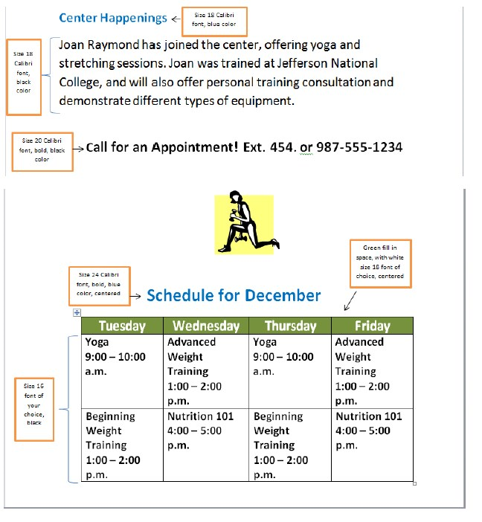

Instructions, Part 2: Check the spelling and grammar, and make any necessary corrections. Save your document as Flyer_Your_Name.

Section 2: Create a Spreadsheet Analyzing Services and Sales
Problem: Tonya would like to review service and sales figures for the center and asks you to assist her in creating a worksheet.
Instructions, Part 1: Start your spreadsheet program. Create a spreadsheet exactly like the one shown in Figure 3 below.

Figure 3: Service and Sales Figures
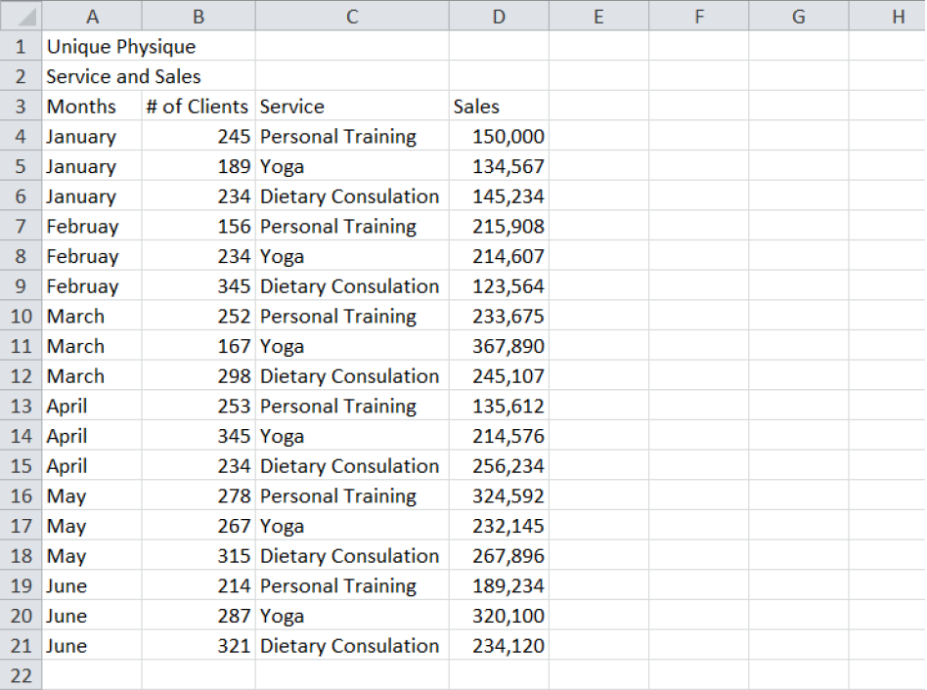
Instructions, Part 2: Perform the following steps.
  - Center and merge cells A1:D1. Make the font size 18 Lucida in a dark green color.
  - Center and merge cells A2:D2. Make the font size 14 Times New Roman in black.
  - Give the cells in Row 3 a light purple fill color.
  - Give the months in Column A a light blue color.
  - Make the headings in Row 3 Times New Roman, bold, size 12, centered, and in black.
  - Make the Months in Column A Times New Roman, bold, size 12, and black.
  - Add the label “Total” in cell A22. Use the SUM function to add the totals for # of Clients and Sales.
  - Format the Sales column to have a $ and zero decimal places.
  - In cell A23, add the label “Average.” In cell D23, enter the formula to calculate the Average Sales.
  - In cell A24, add the label “Maximum.” In cell D24, enter the formula to calculate the Maximum Sales.
  - In cell A25, add the label “Minimum.” In cell D25, enter the formula to calculate the Minimum Sales.
  - Create a thick black border around the entire spreadsheet.
  - Save the file as Service_Sales_Your_Name.

Section 3: Create a Presentation with Images and Transitions
Problem: Tonya plans to promote the center by making a presentation at an upcoming conference for the local Chamber of Commerce. She would like you to create a presentation from her notes to accompany her speech.
Instructions, Part 1: Use the typed notes shown in Figure 4 to create the presentation. Use a theme of your choice.
Figure 4: Presentation Notes
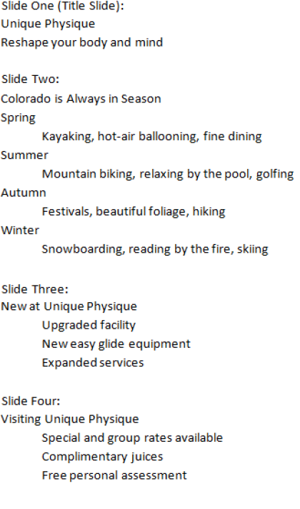
Instructions, Part 2: Perform the following steps.
  - On slide one, change the font size of the title, Unique Physique, to 72, and change the font style to Italic. Change the font color to a complimentary color that enhances your theme.
  - On slide two, insert clip art that represents the information on the slide. Make sure the clip art is sized appropriately.
  - On slide two, format the text by choosing a color of your choice and a font size that works with the image.
  - On slides three and four, format the text by choosing a color of your choice and a font size that is readable.
  - Save the presentation as Center_Presentation_Your_Name.

Section 4: Check Your Work
Using the scoring guides below, check your work, then continue with Part II.
Scoring Guides, Part I

Section 1: Create a Flyer with a Picture and a Table
Criteria | Points Possible | Points Earned
Flyer contains all of the information in Figures 1 and 2. | 10
Flyer is formatted using the guidelines in Figures 1 and 2. | 10
Flyer contains no spelling, grammar, or punctuation errors. | 5
Total Points | 25

Section 1: Create a Flyer with a Picture and a Table
Criteria | Points Possible | Points Earned
Spreadsheet contains all of the information in Figure 3. | 10
Spreadsheet is formatted using the instructions for Part 2. | 10
Formulas in spreadsheet are correct. | 10
Total Points | 25

Section 3: Create a Presentation with Images and Transitions
Criteria | Points Possible | Points Earned
Presentation contains four slides and uses all information from Figure 4. | 5
Slide 1 is formatted according to instructions in Part 2. | 5
Slide 2 is formatted according to instructions in Part 2. | 5
Slide 2 contains clip art that represents the topic. | 5
Slides 3 and 4 are formatted according to instructions in Part 2. | 5
Total Points | 25

