Lab 3.18 Photosynthesis and Respiration
MN State Standards: 9.4.1.2.4 Explain the function and importance of cell organelles for prokaryotic and/or eukaryotic cells as related to the basic cell processes of respiration, photosynthesis, protein synthesis and cell reproduction. 9.4.2.2.1 Use words and equations to differentiate between the processes of photosynthesis and respiration in terms of energy flow, beginning reactants and end products.
Next Generation Science Standards:
HS-LS1-7. Use a model to illustrate that cellular respiration is a chemical process whereby the bonds of food molecules
and oxygen molecules are broken and the bonds in new compounds are formed resulting in a net transfer of
energy.
HS-LS2-5. Develop a model to illustrate the role of photosynthesis and cellular respiration in the cycling of carbon among
the biosphere, atmosphere, hydrosphere, and geosphere.
All questions worth 1 pt unless otherwise noted. Please highlight your answers or use a different color text.

Part 1: Go to: https://biomanbio.com/HTML5GamesandLabs/PhotoRespgames/molecular-models-page.html and start with Task 1

Big Idea: Photosynthesis transforms light energy into stored chemical energy.

Use the light energy to break the bonds in the water molecules:
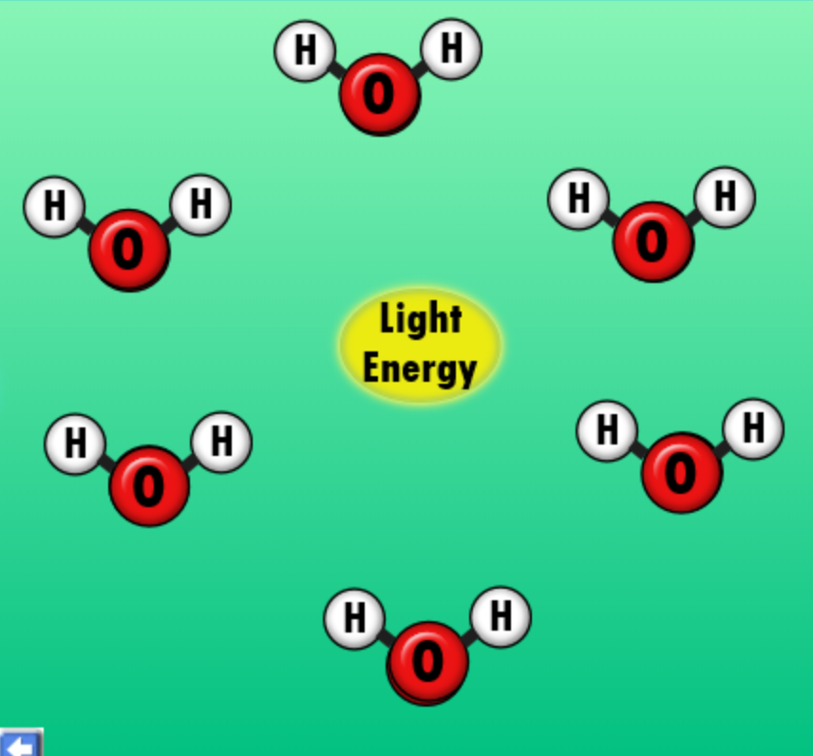
1. What has happened to the light energy? (2pts)

2. How will the atoms be recombined? (2pts)

3. How many hydrogen atoms did you create at breaking the bonds in water?
How many oxygen atoms? (2pts)

Now break the bonds in carbon dioxide use stored chemical energy. Keep hitting next until the chemical energy works
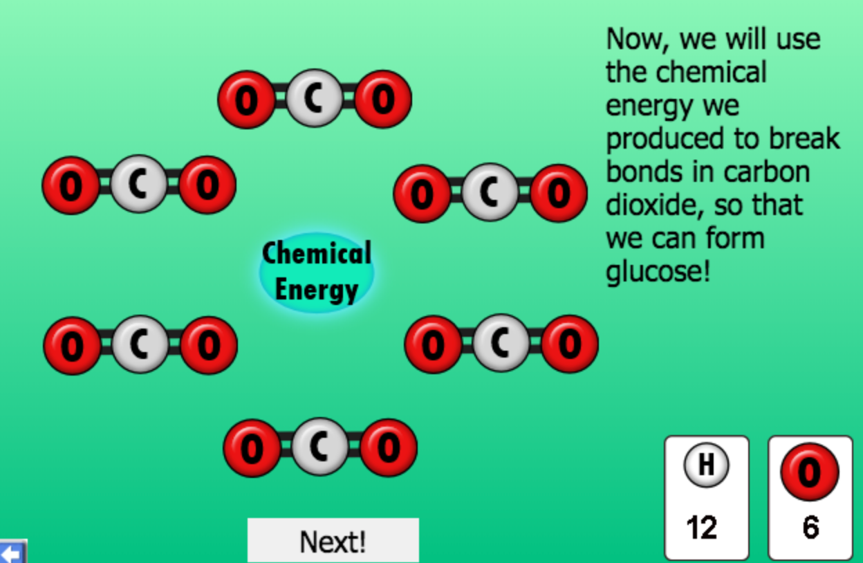

4. How many atom of each element do you have now?
Carbon:
Hydrogen:
Oxygen:
Use your oxygen atoms to make oxygen molecules (O₂):
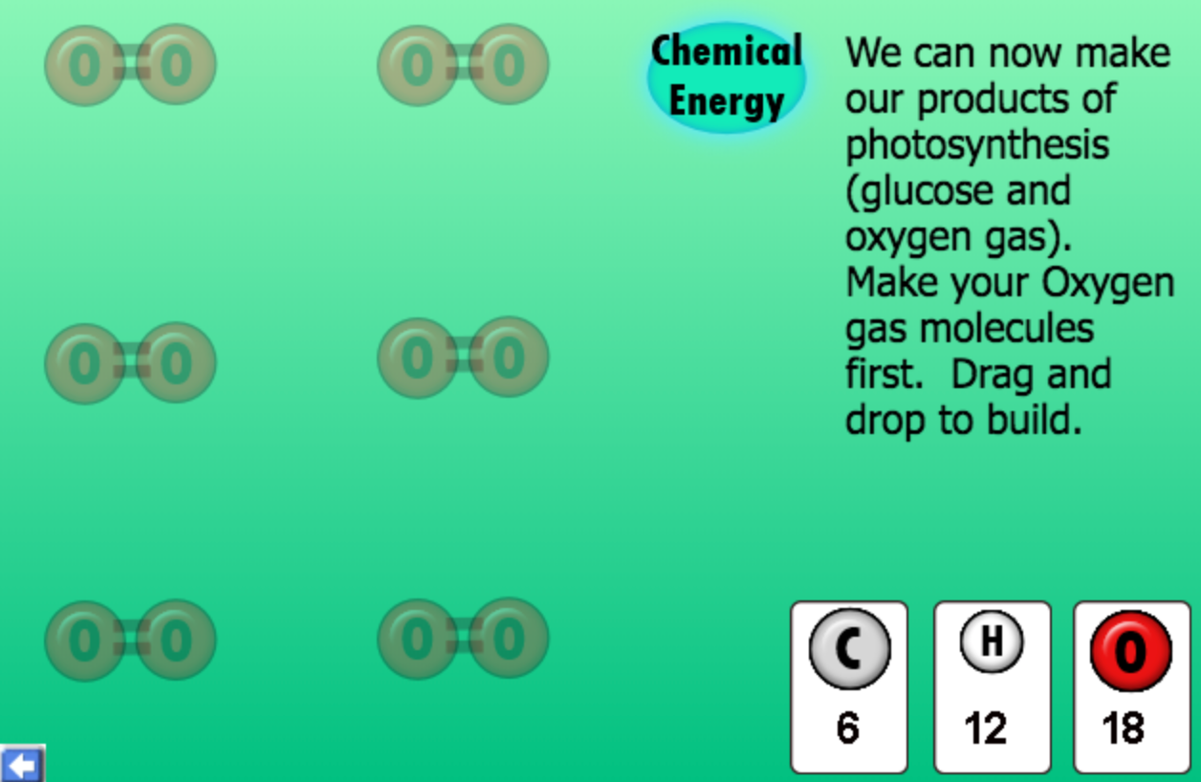
How many oxygen molecules did you make?

5. If another student told you that plant do photosynthesis to make oxygen, what would you explain to them? (2pts)

6. After you make oxygen molecules, what can you make with the remaining atoms? Give the chemical formula and the name. (2pts)

Next use your remaining atoms to build a sugar molecule:
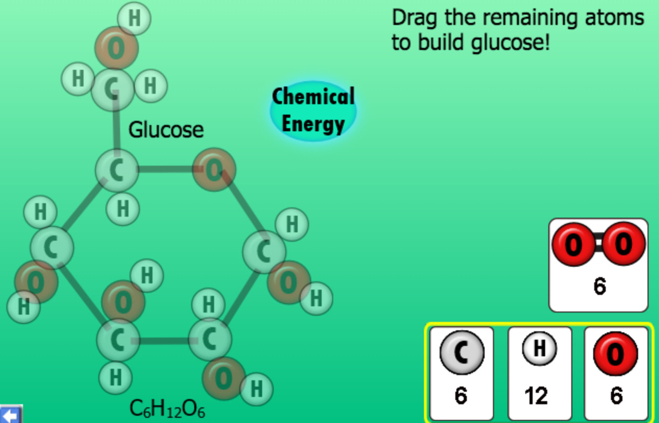
7. Describe the positions of the 6 oxygen molecules. Include: Which ones are attached to one carbon? Which one is attached to 2 carbons? (2pts)

8. Describe the positions of the 6 carbon molecules. How many are attached to two carbons? How many are attached to one carbon? (2pts)

8. What was produced after the bonds were formed in glucose?

9. You started out with water (H₂O) and carbon dioxide (CO₂) and ended up with glucose (C₆H₁₂O₆) and oxygen (O₂). How did that happen? Explain. (2pts)

Now go to Task 2 in the sim. It should say, “Construct and revise an explanation based on evidence for how carbon, hydrogen, and oxygen from sugar molecules may combine with other elements to form amino acids and other large carbon based molecules.”

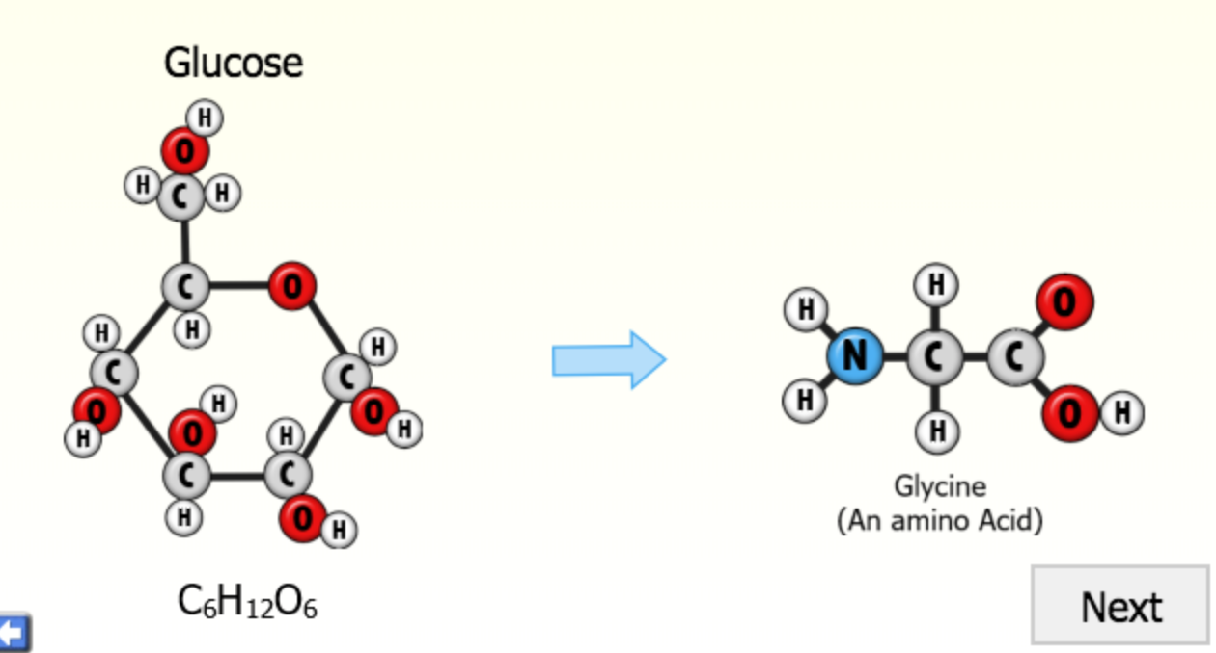
Assemble a Glycine amino acid molecule from glucose atoms.
10. What element is missing from glucose you need to form the amino acid?

11. Why do plants need nitrogen fertilizer? (2pts)

Part 2, Go to: https://biomanbio.com/HTML5GamesandLabs/PhotoRespgames/molecular-models-page.html

Review: Notice that in cellular respiration, bonds in food (glucose) and oxygen are broken and the bonds in new compounds (carbon dioxide and water) are formed resulting in net transfer of enery (ATP)
Below is an overview of what takes place.
Please click next to continue with the lab.

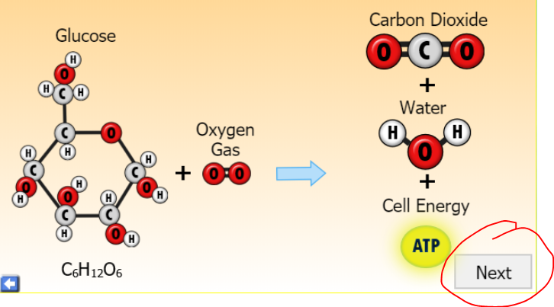 | 13. What is released when the bonds are broken?
12. (2pts) You will need to click and drag each of the atom to the matching element box. When you break down all of the bonds in Glucose you end up with:  ______ C  ______H  ______O | Go to the Next button, then click on each molecule of oxygen (O₂) to break all of the molecules apart. Drag and drop all of the oxygen atoms to the appropriate box.

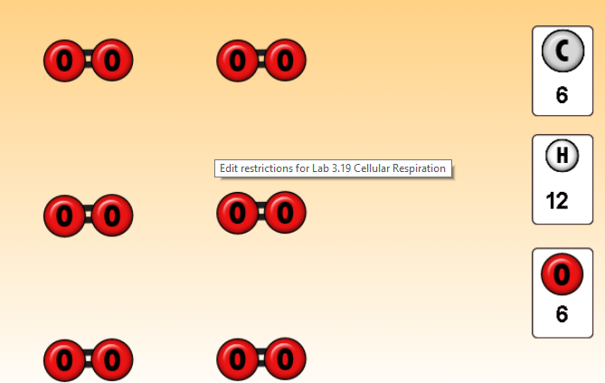 | 14. How many total oxygen molecule are going to be used in the reaction?  15. After all of the oxygen atoms are removed, how many total oxygen atoms will there be in this reaction?

Click the next screen.

16. How many CO₂ Molecules are made?

17. On the next screen how many H₂O molecules are made?

18. How many molecules of ATP are created in this reaction?

19. Put it all together. How many molecules of each reactant and product is used in this reaction? (2pts)

_____C₆H₁₂O₆ + _____O₂ → _____CO₂ + ______H₂O

Part 3: Photosynthesis Interactive
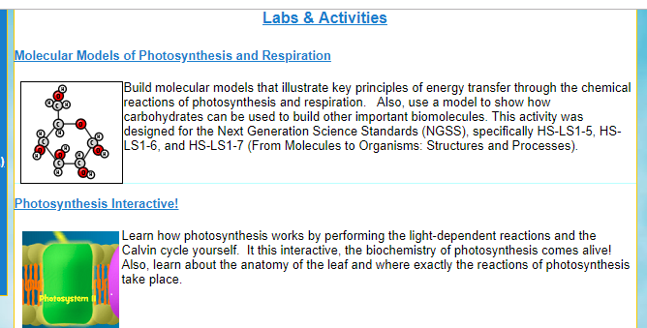 Go to: https://biomanbio.com/HTML5GamesandLabs/PhotoRespgames/photoresp.html and click on the “Photosynthesis Interactive!”
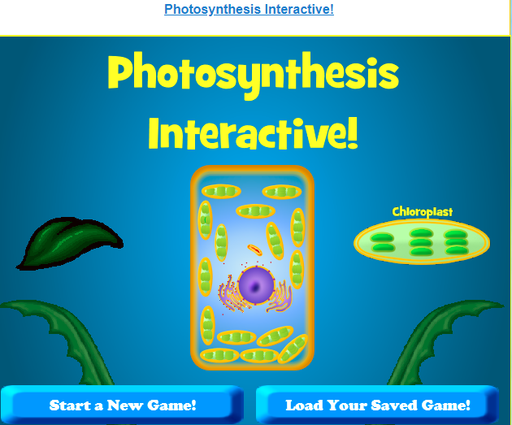  Click on “Start a New Game” | Pilot your ship to the site of photosynthesis!  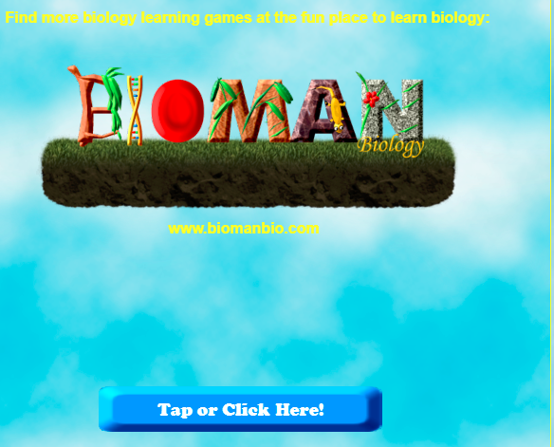
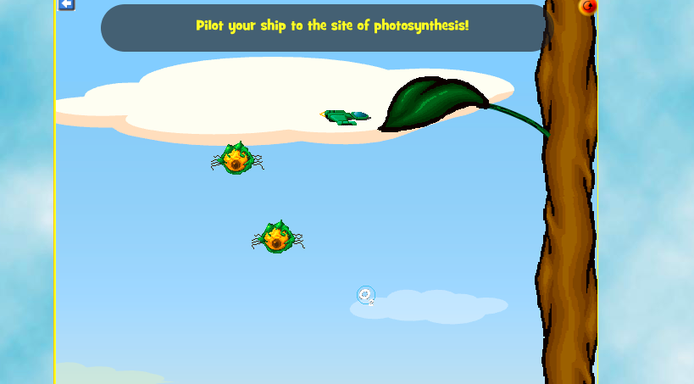 | Inside the leaf… 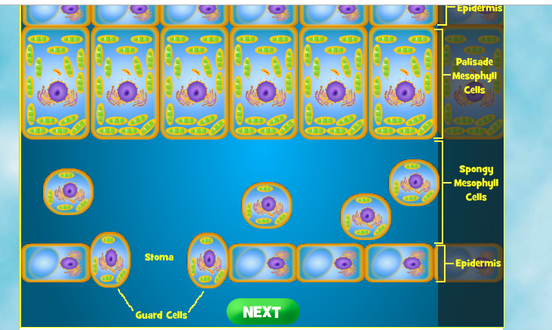  Follow the CO₂
20. Which type of leaf cells are the most responsible for photosynthesis? | Fly into the organelle where photosynthesis takes place. 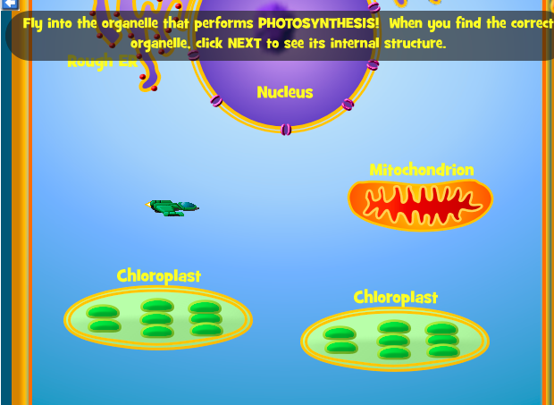  21. What is the name of this organelle?
Go back to the main menu and click on Light-Dependent Reactions:  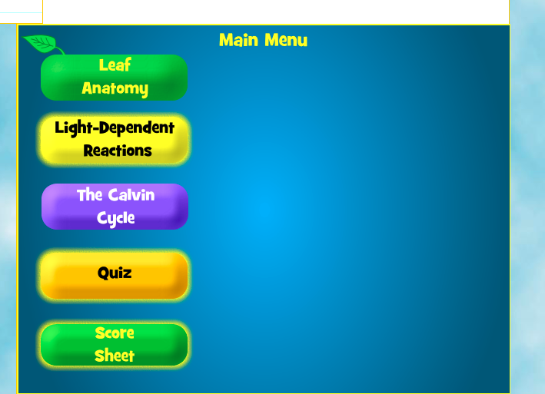  23. What is the name of the structure inside of the chloroplast where the light-dependent reactions occur? | Zoom in on the thylakoid membrane:  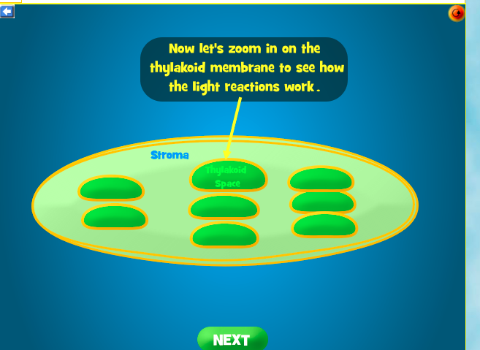  24. Where does the Calvin Cycle take place?
Watch an animation of the Light-Dependent reactions:  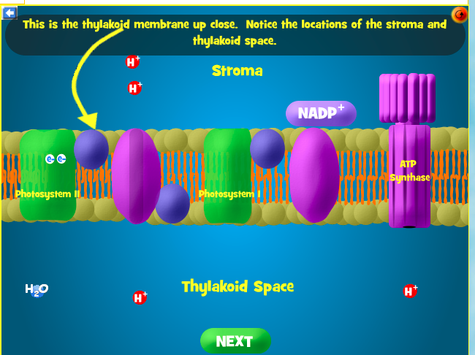 | 25. What does light do when it strikes the chlorophyll molecules of photosystems I and II? (2pts)  - Light causes electrons to get excited (gain energy) and travel down an electron transport chain embedded in the thylakoid membrane.  - Light causes glucose to be synthesized directly inside the chlorophyll molecules of the photosystems.  - Light causes the conversion of water into carbon dioxide, oxygen, and electrons.  - Light directly causes carbon dioxide to attach to RuBP during the carbon fixation stage of the Calvin Cycle.
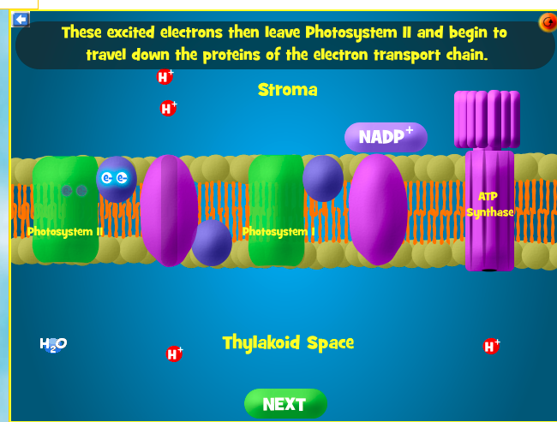 | 26. After light excites electrons and they leave Photosystem II to travel down the first electron transport chain, how are these electrons replaced to Photosystem II?  - Oxygen is reduced and the electrons are given to the chlorophyll molecules of photosystem II.  - Water is split, and the electrons are given to the chlorophyll molecules of photosystem II.  - Carbon dioxide is split, and the electrons are given to the chlorophyll molecules of photosystem II.  - Hydrogen undergoes fusion, and the electrons are given to the chlorophyll molecules of photosystem II.
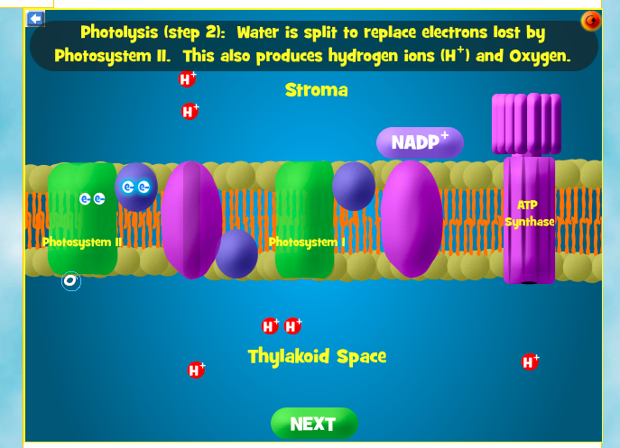 |  | 27. The splitting of water at photosystem II is known as _____ and results in the production of _____.  - Photolysis: oxygen, hydrogen ions (protons), and electrons that are given to photosystem II.  - Photosynthesis; carbon dioxide, G3P, and electrons that are given to photosystem II.  - The Calvin cycle; carbon dioxide, G3P, and electrons that are given to photosystem II.  - Chemiosmosis; oxygen, hydrogen ions (protons), glucose and electrons that are given to photosystem II.

Click next until you get to…
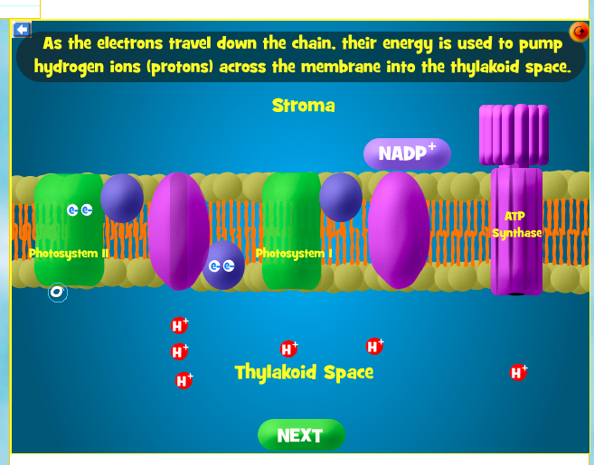 | 28. As the electrons travel from photosystem II down the first electron transport chain, their energy is used to…  - Form oxygen, water, NADPH and glucose.  - Pump hydrogen ions into the thylakoid space, producing a concentration gradient that will later be used by ATP synthase to form ATP.  - Pump hydrogen ions into the stroma, producing a concentration gradient that will later be used by an enzyme to form ADP and phosphate.  - Create glucose directly.
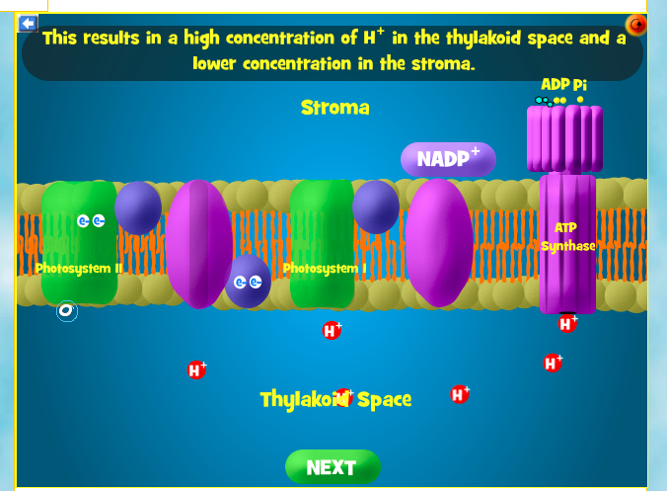 | 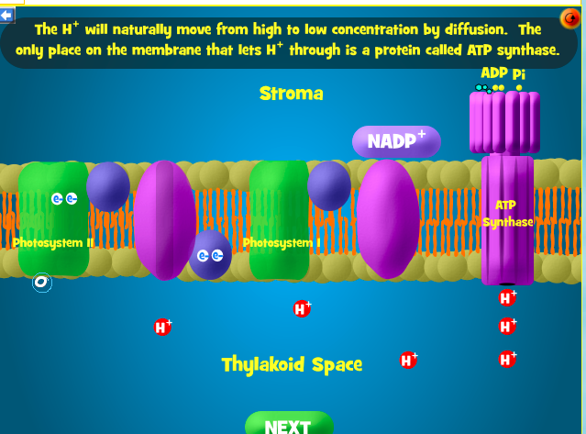
29. Why do hydrogen ions flow from the thylakoid space to the stroma through ATP synthase?  - They are pumped actively through ATP synthase. This uses up ATP energy and causes the production of ADP and phosphate.  - They flow through the Calvin cycle and produce light.  - They flow passively from high to low concentration via facilitated diffusion. As they flow through ATP synthase, the enzyme spins and produces ATP.  - Hydrogen ions do not actually flow from the thylakoid space to the stroma. They flow the opposite way. | 30. After electrons get excited by light a second time (at photosystem I), where do they go?  - They travel down a second electron transport chain and are donated to ADP, which is then converted to ATP.  - They remain excited and then travel to photosystem II where they get even more excited until they spontaneously combust.  - They travel down a second electron transport chain and are donated to oxygen which then bonds to hydrogen ions to form water.  - They travel down a second electron transport chain and are donated to NADP+ which becomes NADPH (an electron carrier).

Click next until…

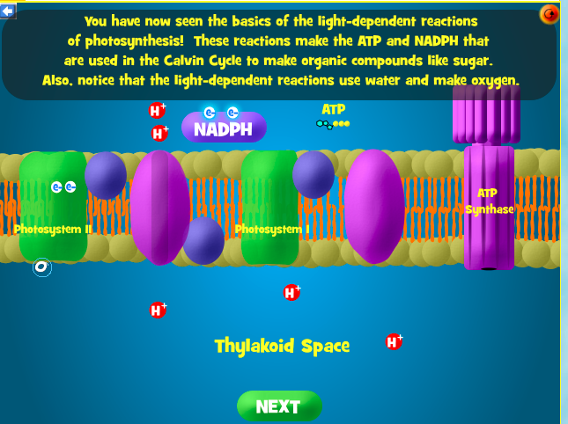 | 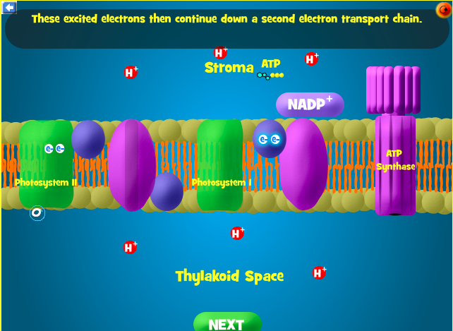
Continue to the end of the Light-Dependent reactions: | 31. Which products of the light-dependent reactions are used in the Calvin cycle to help form reduced organic compounds?  - Oxygen, ATP, NADPH, and CO₂  - Water and CO₂  - Light, water, and CO₂  - ATP and NADPH

Return to the Main menu and click on Calvin Cycle: | 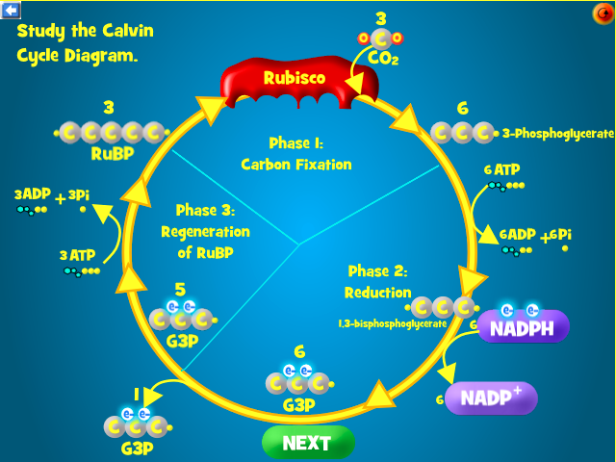
 | Drag an RuBP and CO₂ to the Rubisco enzyme.
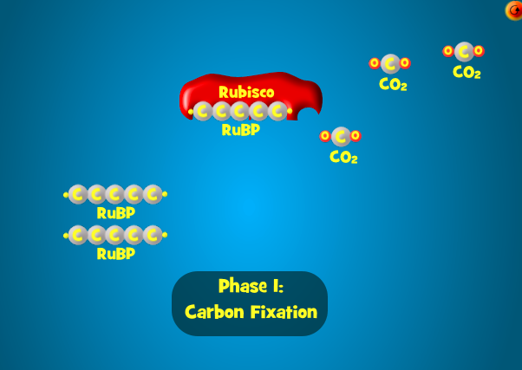 | 32. What happens?  - The enzyme Rubisco attaches CO₂ to RuBP, causing the formation of molecules of 3-phosphoglucerate.  - Energy from ATP and electrons from NADPH are used to reduce 3-phosphoglycerate to form G3P molecules (which can be used to form other organic molecules such as glucose).  - The remaining G3P molecules that have not exited the cycle are used to re-form RuBP through a series of chemical reactions, so that the Calvin cycle can continue.  - Oxygen is produced through this process.

Keep clicking through the simulation. Combine the 3-Phosphoglycerate molecules with ATP and NADPH.

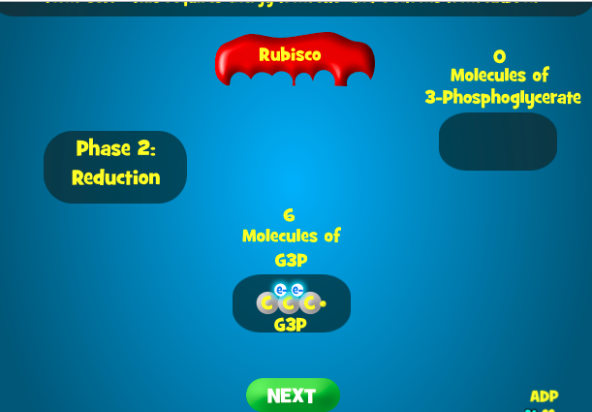 | Click through all stages of Phase 3: Regeneration of RuBP.  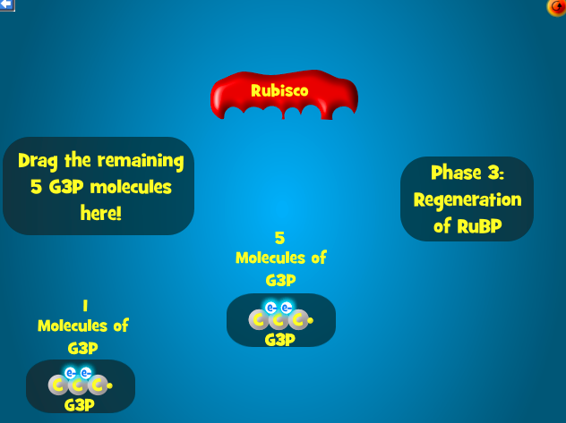
33. What happens during the reduction stage of the Calvin Cycle (light-independent reactions)?  - The remaining G3P molecules that have not exited the cycle are used to re-form RuBP through a series of chemical reactions, so that the Calvin cycle can continue.  - Oxygen is produced through this process.  - The enzyme Rubisco attaches CO₂ to RuBP, causing the formation of molecules of 3-phosphoglycerate.  - Energy from ATP and electrons from NADPH are used to reduce 3-phosphoglycerate to form G3P molecules (which can be used to form other organic molecules such as glucose). | 34. What happens during the regeneration stage of the Calvin Cycle (light-independent reactions)?  - The remaining G3P molecules that have not exited the cycle are used to re-form RuBP through a series of chemical reactions, so that the Calvin cycle can continue.  - Oxygen is produced through this process.  - The enzyme Rubisco attaches CO₂ to RuBP, causing the formation of molecules of 3-phosphoglycerate.  - Energy from ATP and electrons from NADPH are used to reduce 3-phosphoglycerate to form G3P molecules (which can be used to form other organic molecules such as glucose).

25. Writing Wrap Up: (12pts) Use the following words in a paragraph in a way that shows you know what they mean in the context of Lab 3.18: cellular respiration, photosynthesis, glucose, carbon dioxide, water, light energy, chemical energy, chloroplasts, hydrogen ions, electrons, ATP synthase, and Calvin Cycle. Please highlight, bold, or use a different color font for the vocab words in your paragraph.

Yeah! You are done. Check to make sure you have answered ALL the questions and put this in the Lab 3.18 assignment folder.

